**Analysis of factors affecting music rating**

Vincent Pisztora

1. Introduction

The experimenter is interested in the influence of three main experimental factors (Instrument, Harmony, and Voice) on the rating of music as both Classical and Popular. Additionally, there is interest in whether any additional subject level factors are also predictive of ratings. Data prepared for analysis was collected on 70 subjects from a local university. Analysis conducted on this data showed Instrument (being most influential), Harmony and Voice to be significant predictors of Classical rating, and only Instrument to be predictive of the Popular rating. Additional subject level factors were also found to be significant in score prediction in both Classical and Popular sound samples. Finally, an interaction effect between the subject’s status as a musician also had an effect on ratings, although this effect was mostly restricted to Classical rating.

1. Methods

To determine the relationship between experimental factors and subject level factors, several models were fitted to both Classical ratings and Popular ratings. In both cases, a multiple linear regression, a standard repeated measures model, and a model containing random experimental factor interaction with the subjects was fitted. Utilizing AIC and BIC criterion as comparative metrics, the random interaction model was shown to be the most predictive of both Classical and Popular ratings.

1. Results
   1. Classical Rating

Interpreting the final model, it was found that in addition to the effects of the three experimental variables, the amount a subject listened to classical and contemporary music, as well as various factors measuring a subject’s musicality had a significant predictive effect on rating. It was also found that self-reported musicians rated music differently than non-musicians (generally given a piece a less classical rating). Please see Fig. 1 for more detail.

* 1. Popular Rating

Interpreting the final model, it was found that in addition to the effects of the three experimental variables, the amount a subject listened to contemporary music, as well as various factors measuring a subject’s musicality had a significant predictive effect on rating. It was also found that self-reported musicians rated music differently than non-musicians (generally given a piece a less popular rating). Please see Fig. 2 for more detail.

1. Appendix

Fig 1. Classical Model

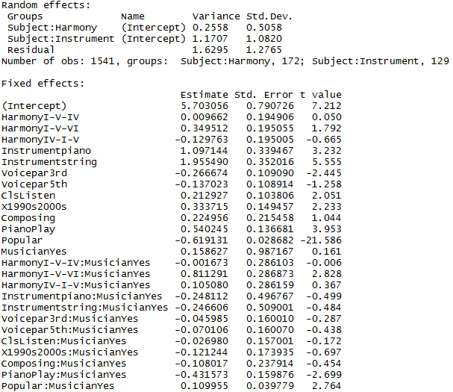

Fig 2. Popular Model

