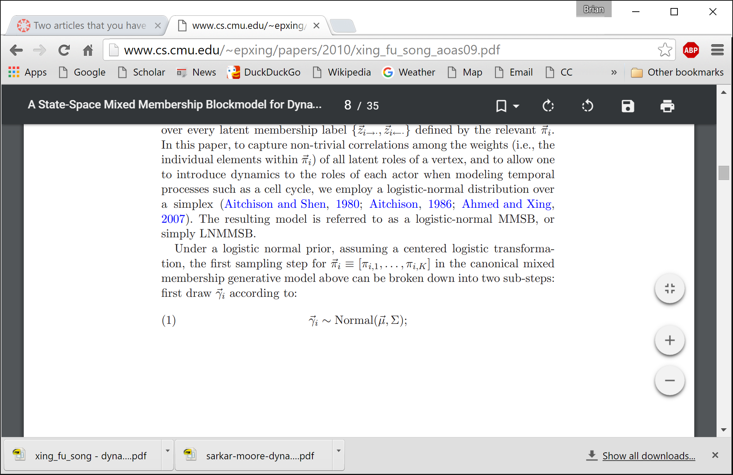

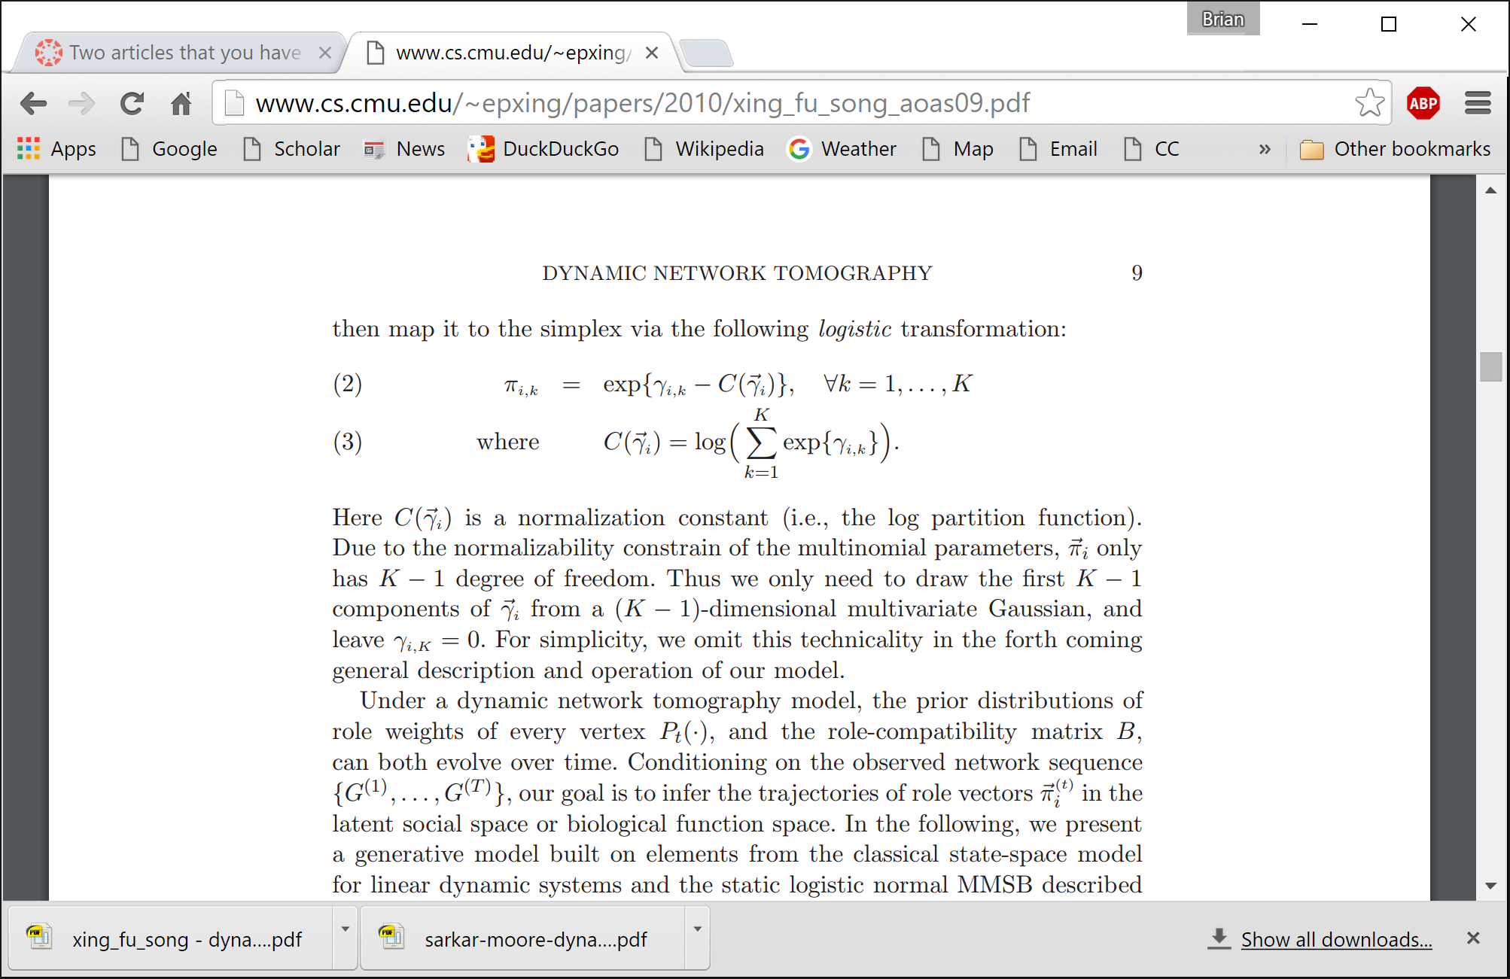

* Concrete, direct description.

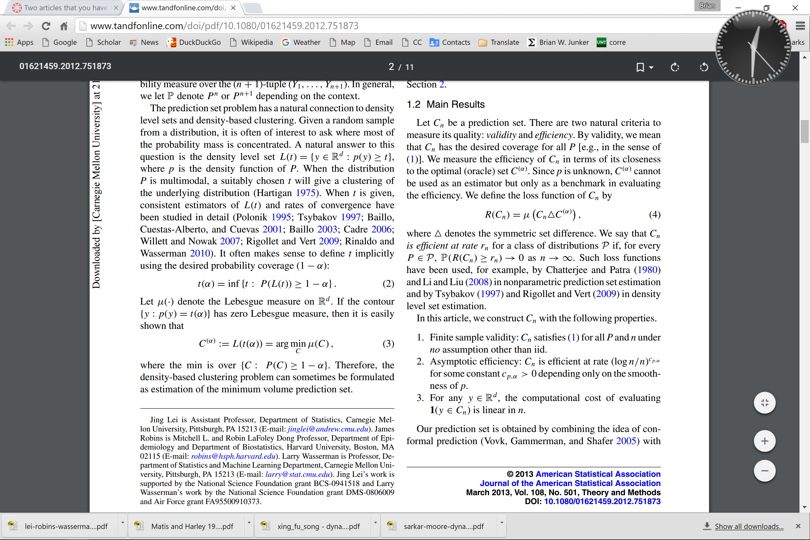

* The authors are very clear about the two issues they are concentrating on namely validity and efficiency and very clearly describe both. Every notation that is used in the paper as well as the goals to be achieved are very beautifully presented in the same paragraph. This gives a very clear picture to the readers as to why the variables are being defined and what to expect from them. It is also very interesting to note that every sentence in the paragraph starts with something we know from before. The itemization of the goals is also very nice.

In many situations a researcher does not have the framework of a population about which he tries to estimate some properties. The lack of information about the framework of the population makes it impossible to create a systematic sampling procedure of the elements in the population. In such situations substitutions are often made by using a framework directly or indirectly related to the elements of the population. For example, in order to estimate the number of diabetics in a nation, households can be selected as a sample frame. A researcher may randomly select households, and then collect information from diabetics fond in the selected households or from diabetics who are related to the selected households (Sirken et al. 1975). In order to estimate the number of people with neurological problems, clinics and hospitals may be selected as a sample frame (Sirken, 1975). In these examples, households, clinics, or hospitals are called ``enumeration units'' in sample surveys, while diabetics and people with neurological problems are called ``populations elements'' whose parameters are being estimated. The multiplicity method in sampling can be used when enumeration units in the sample surveys are not identical to the population elements (Sirken, 1974). When different units are used to select population elements, it is essential to link the two distributions. In other words, it becomes essential to estimate the probabilities of selecting population elements from the probabilities of selected enumeration units.

* This paragraph conveys a complex idea, but by giving an example it makes it a lot easier to imagine and keep track of the households and the individuals. It is long, but by giving examples it actually makes the concepts easier to understand. This paper defines concepts that might be as simple as population elements, and it holds the reader's hand through the paragraph.

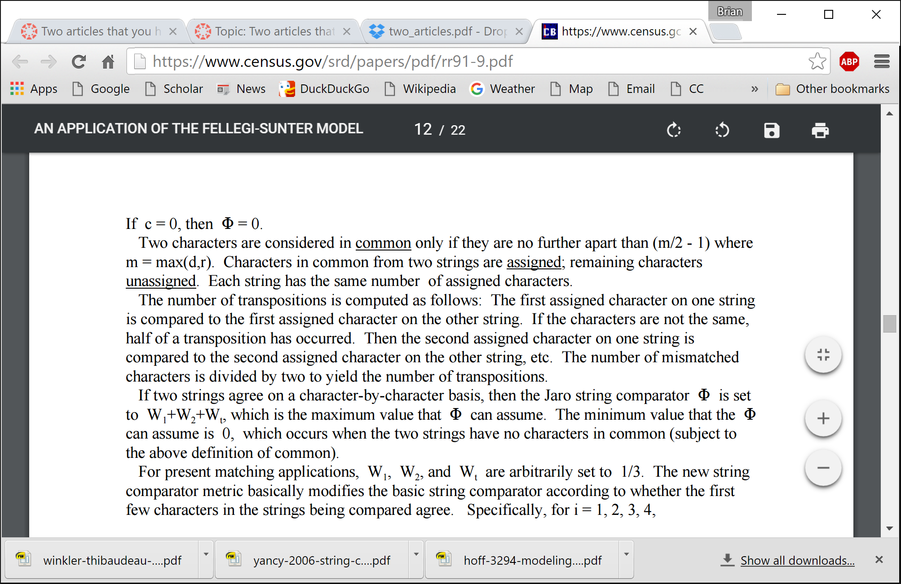

* This passage is easy to read because each paragraph contains only one idea.
* The first paragraph right away indicates that the author is talking about characters in a string and how close they have to be to be considered in common. The reader is then told simply what happens to the characters in common and also the other characters. The author even even emphasizes that each string has the same number of assigned characters and closes the main idea in the paragraph.

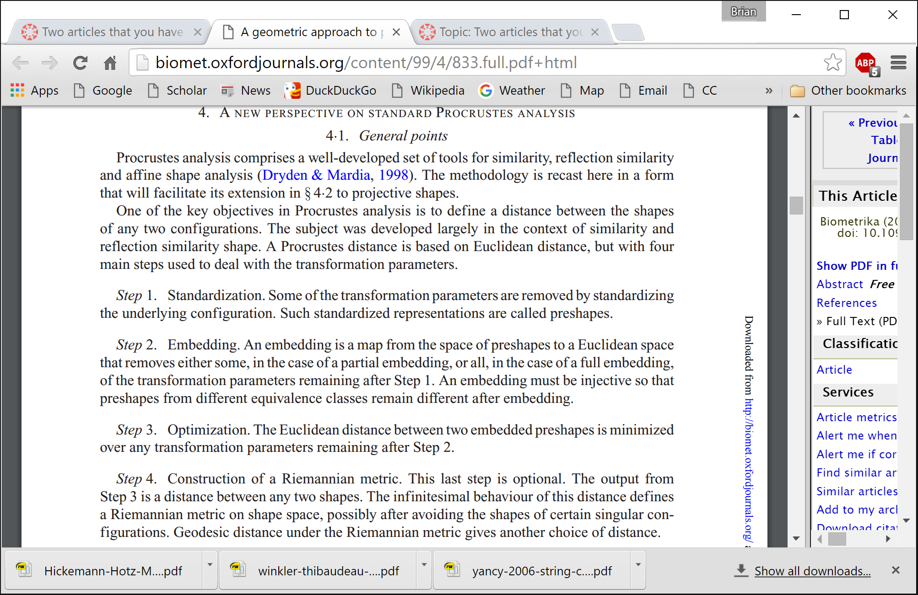

* Clear, straightforward procedural description.

Lineup ROCs look somewhat different from diagnostic ROCs in the medical literature because the HR and FAR do not each span the range from 0 to 1. For example, a diagnostic test in medicine that uses the most liberal cutoff will have a HR of 1.0 and a FAR of 1.0 (i.e., everyone tested will be diagnosed as having the disease), but the highest FAR for a lineup will be lower. Consider, for example, an eight-member lineup consisting of one suspect and seven foils, as in Brewer and Wells (2006). In a fair lineup involving an innocent suspect (one who does not look more like the perpetrator than the other seven members of the lineup), the maximum FAR—which would be obtained if participants used such a liberal confidence cutoff that they always identified someone from a target-absent lineup—would be 1/8, or 0.125. Thus, unlike the ROC data shown in Figures 2 and 3, in which the FAR on the x-axis ranges from 0 to 1, the FAR for a (fair) eight-member lineup will range from only 0.0 to 0.125. In addition, unless memory is perfect, the HR will be less than 1.0 even if participants always identify someone from a target-present lineup. Generally speaking, a lineup ROC looks like a truncated version of the ROCs shown in Figures 2 and 3 (cf. Clark et al., 2011).

* This paper seemed a bit too wordy for my taste; but it was also one of the first papers published in the eyewitness identification literature proposing ROC analysis as a potential tool, so I understand why its lengthiness was necessary.
* It's a very easy-to-read paper because much of the writing is conversational, and many of the ideas are illustrated with dummy examples before they're applied in a new way to eyewitness identification.

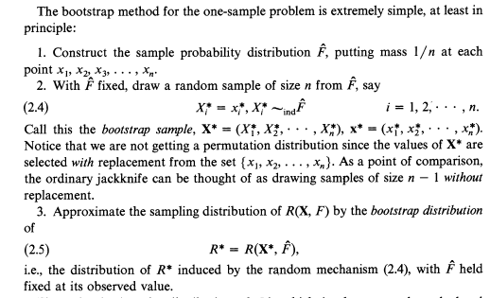

* Describing a process or algorithm as a numbered list makes it much easier to follow.  It is easier go back and remind myself what the previous step was I read through the sequence.  But as opposed to a short bulleted list there is still enough room for some explanation with each step to give the reader a better overall understanding.

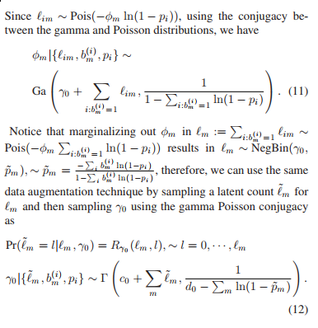

* Notice that they give some discussion to the updates and explain a little more.  Plus the important equations are offset as equation environments. Made it much easier to read and extract what I needed from it.

Table 2 lists the basic set of plyr functions. Each function is named according to the type of input it accepts and the type of output it produces: a = array, d = data frame, l = list, and _ means the output is discarded. The input type determines how the big data structure is broken apart into small pieces, described in Section 3.1; and the output type determines how the pieces are joined back together again, described in Section 3.2.

* This article does a great job explaining the idea behind the core details of the paper, and slowly building the readers into the details. For example, in this paragraph the author has formalized what he had hinted at informally in the examples of the previous section, and it feels like an appropriate time to introduce this key idea. Once this idea is in mind, the details of the section become much easier to understand.