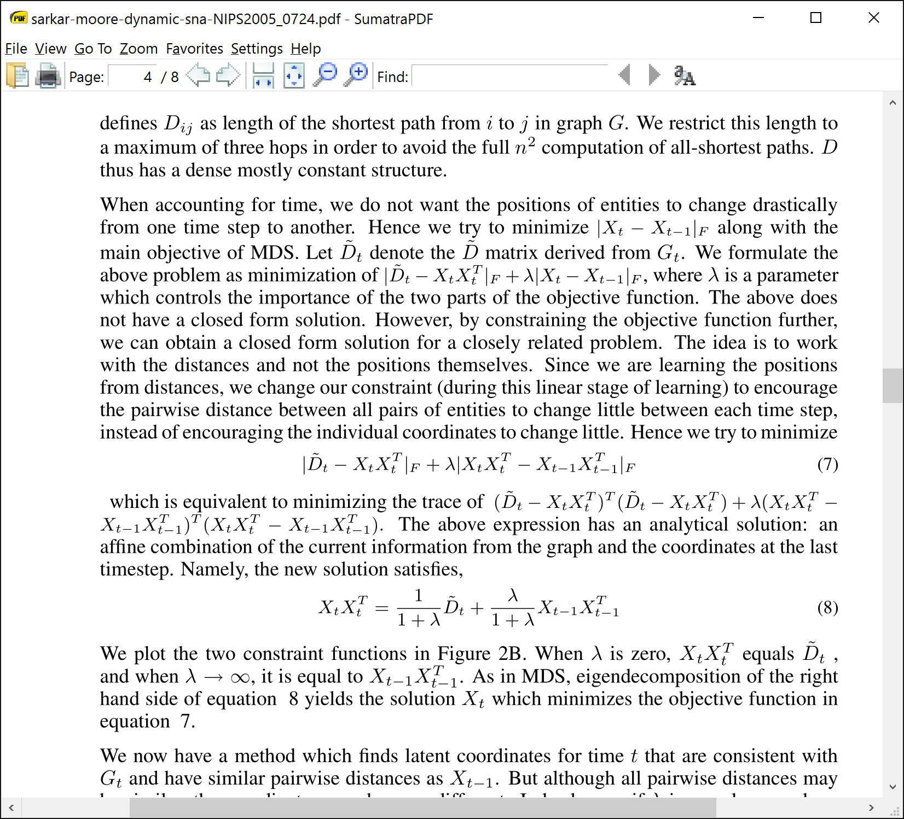

* Repetitive use of “above”. It becomes ambiguous what the antecedent of “above” is.
* In the first case we could say “this minimization problem” and in the second, “minimizing this objective function”. If space permitted, setting the objective function out as a numbered equation might also help.

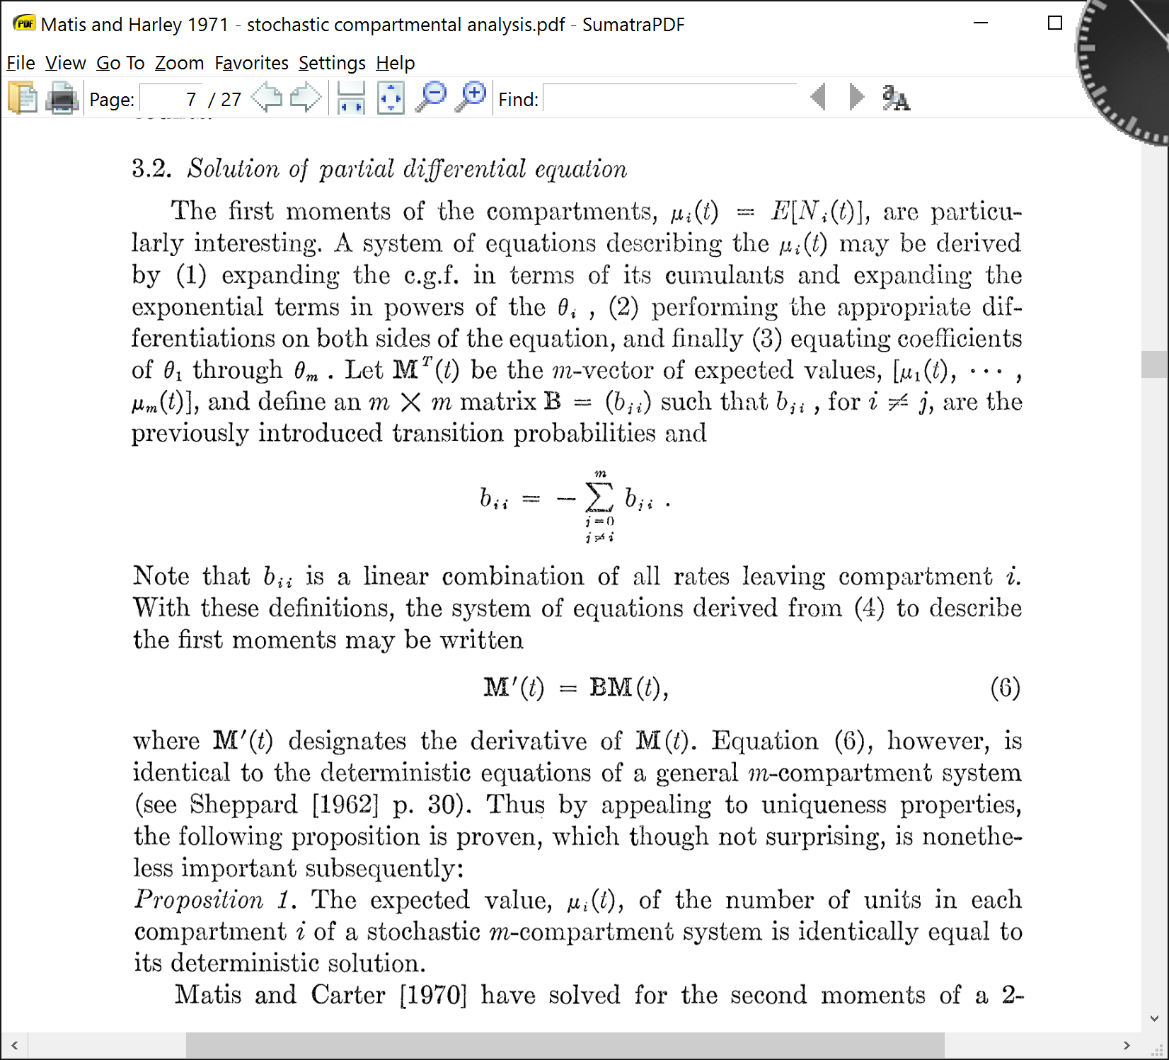

* Not clear which cumulant generating function is meant.
* Not clear what the appropriate differentiations are.

In the typical household survey, each individual with the attribute would be reported by one and only one household in population $\pi$ --- the household of which he is a resident. Hereafter, this will be referred to as the conventional survey. Consider next the household survey with multiplicity. In this type of survey, each individual with the attribute would be reported by at least one household---the household of which he is a resident. In addition, he would be reported by other households in population $\pi$ of which he is a nonresident as specified by the multiplicity rule adopted in the survey. The total number of households in population $\pi$ reporting the individual is referred to as his multiplicity. For example, if the survey adopts the multiplicity rule, ``siblings report each other,'' the multiplicity of an individual is equal to the number of different households in $\pi$ in which either he or one of his siblings is a resident.

* This paragraph is trying to convey a complex concept, and it is very confusing the first time you read it. It is difficult to keep track of which household, which individual, and which attribute he is referring to. He doesn't define what a counting rule is, and if you know about survey methodology this might be easy to understand, but if you are not used to reading literature in that subfield it is frustrating jargon.

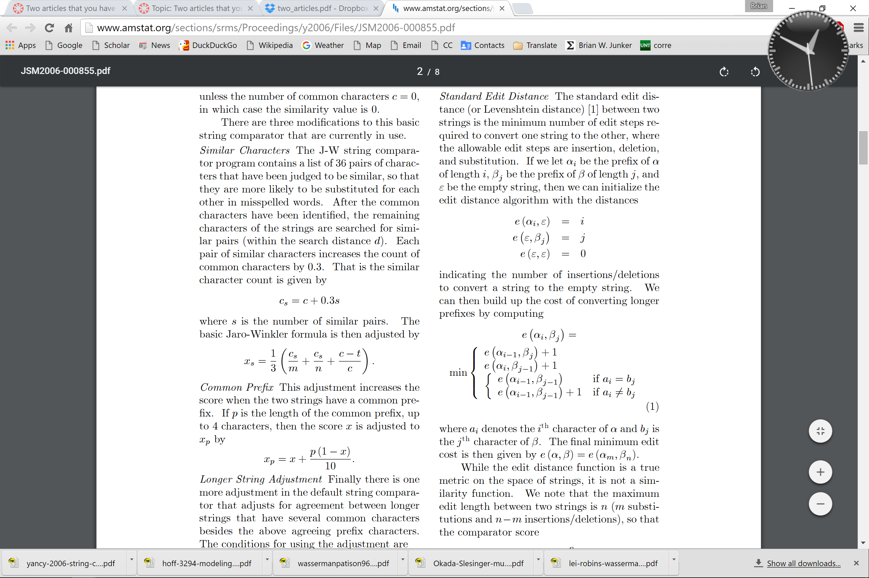

* The italic in-line header is an unfamiliar convention.
* The variables are defined earlier in the article, but “let $\alpha_i$ be prefix of $\alpha$” may have a grammatical error (“the” prefix?), overloads the notation $\alpha$, and does not define what a prefix is.
* The un-numbered equations use e and \epsilon together, which can be confusing. Also, using “e” for this function is unusual in the literature, which uses “s” or “d” instead.
* Equation (1) is laid out in a way that is difficult to parse.

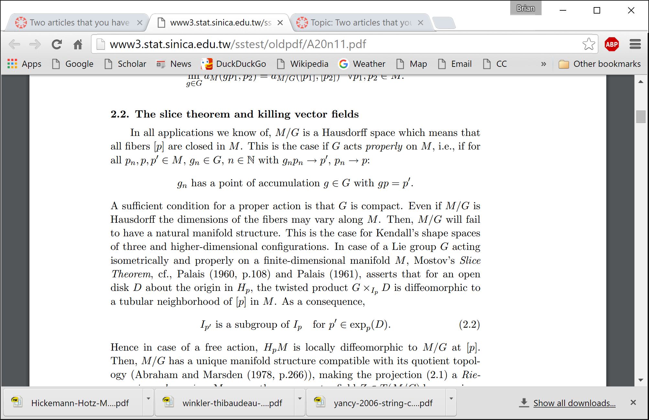

* The author missed the preliminary introductions to some of the terms, or at least the citations of these terms.

The condition that elicits superior discriminability is the one with the ROC curve farthest from the chance diagonal. The statistical evaluation of ROC curves involves comparing the areas under the respective curves, with the condition exhibiting superior discriminability reflected by the largest area under the ROC curve. Lineup ROCs are constructed using only suspect IDs (perpetrator and innocent suspect); foil IDs are excluded, just as they are from probative value calculations, because they involve the identification of known innocents. However, the exclusion of foil IDs means that the resulting lineup ROCs are truncated, because as the response bias becomes more liberal the increased likelihood of choosing results in more foil and suspect choosing, not just more suspect choosing. Consequently, a partial area under the lineup ROCs (pAUC) must be computed. That is, rather than computing the area under an ROC curve as the false ID ranges from 0 to 1, researchers compute the pAUC by restricting the range of the false IDs (see Gronlund et al., 2014 for a tutorial).

* Under-explained concepts
* phrases and terms used that weren't explained previously in the article.
* Ideas weren't fully explained before moving on to the next topic, which made it hard to see what point they were trying to make.

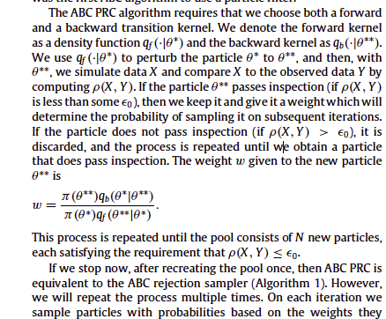

* Paragraph form not as transparent as numbered or bulleted list for describing a procedure or algorithm.

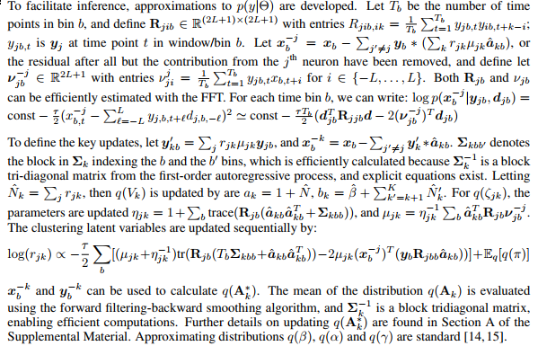

* This paper is not so bad in the text; but what I really wanted out of it was some update equations.  In the extract these are given in the course of a paragraph and just looking at it as a wall of text is intimidating.  I had to end up rewriting it as a table to actually begin to understand what was going on.

Spatial micro-simulation is a methodology aiming to simulate entities such as households, individuals or businesses in the finest possible scale. This process requires the use of individual based microdatasets. The package presented in this work facilitates the production of small area population microdata by combining various datasets such as census data and individual based datasets. This package includes a parallel implementation of random selection with optimization to select a group of individual records that match a macro description. This methodological approach has been used in a number of topics ranging from measuring inequalities in educational attainment (Kavroudakis, Ballas, and Birkin 2012) to estimating poverty at small area levels (Tanton, McNamara, Harding, and Morrison 2007). The development of the method over recent years is driving computational complexity to the edge as it uses modern computational approaches for the combination of data. The R package sms presented in this work uses parallel processing approaches for the efficient production of small area population microdata, which can be subsequently used for geographical analysis. Finally, a complete case study of fitting geographical data with the R package is presented and discussed.

* It was unclear to me what the major contribution of this paper was. It introduces itself as a spatial micro-simulation paper, but it seems after re-reading the goal is to provide data-sets for individuals to use for spatial micro simulation. If this were the case, it's unclear what types of "macro description" were meant, and what exactly was being processed in parallel. In the end, reading the abstract of this raised many questions about the main idea.