“Drafty Draft” for Group D (Matt Vela and Movses Musaelian)

Academic Major and Political Attitudes

Section 1

Our survey project regards the relationship between academic major and political attitudes. In gauging this relationship, we would like to see if certain stereotypes regarding people taking certain academic majors really do hold among Carnegie Mellon students. Given this, we would like to see if it is possible to make certain inferences regarding quantitative versus more humanitarian oriented students as it comes to these beliefs. In attempting to gauge this, we will observe the differences between our several groups and see what differences are significant. We recognise that such differences may be minute and not give any significance which would give us an interesting assessment of the Carnegie Mellon undergraduate population. We hope that a significant result will provide the community an interesting perspective on our diverse population - and in addition provide an interesting comparison with other similar studies.

There have been a few studies done on this subject manner. One of the most relevant ones was a study done at University of Minnesota which basically pursued the same research question as ours, but used different methodology, for example a much shorter and concise questionnaire.

“Choice of Major and Political Attitudes: A Study of University of Minnesota Students” , Spring 2010, (Rachel Gage, Jennifer Zick, Kaylie Tully, and Elaina Simon), Department of Psychology, University of Minnesota. Published in University of Minnesota Undergraduate Journal of Psychology (Sentience).
http://www.psych.umn.edu/sentience/files/Gage_2010.pdf

Another source found was a university article which investigates the liberalisation of students’ socio-political orientations. The article however does not employ a survey, but provides an extensive history and analysis regarding this trend which is crucial to this topic.

“Higher education and sociopolitical orientation: The role of social influence in the liberalisation of students” Brianne Hastie, University of South Australia, European Journal of Psychology of Education 2007

This third article examines the argument that political orientation is significant in affecting academic success in university. The sample size utilised in the paper are undergraduate students at an American university and their respective grades. The statistical analysis includes multilevel regression modelling.

“What’s in a Grade? Academic Success and Political Orientation” Kemmelmeier, Danielson, Basten, Personality and Social Psychology Bulletin, 2005

The fourth paper is regarding voting behaviour of parents and their children at university. The paper includes some useful data regarding political attitudes of students and since this research was done via survey, the questionnaire is shown in the paper.

http://www.manchester.edu/oaa/Programs/MISC/files/documents/KnightBriannaandLupkinAlycaandMcFaddenKaty-Paper.pdf

Section 2

The sampling frame for this topic includes the undergraduate students at Carnegie Mellon. However, this sampling frame has to be narrowed down to students who have a declared primary major; hence, many first year students may become illegible units. Given this, the units were randomly sampled from email addresses in C-book, rather than exclude all the first year students, we had our first question “filter” students who do not have declared majors. We divided our frame into 7 groups (CIT, MCS, SCS, SDS+Statistics, CFA, Tepper+Econ, Humanities) which represent comparable majors within. Since we do not have any prior knowledge regarding the probabilities of these groups, we decided against doing stratified sampling and rather sampled evenly from each group.

Rather than have the target population be general US undergraduate students, it is confined to just Carnegie Mellon undergraduates. A target population of US undergraduate students would yield substantial coverage errors and given our resources - it is best to make our inference regarding the sphere of Carnegie Mellon. Obviously, our sample selection is a small part of this population and coverage error could come from over representation in a certain school or major. Another source of error could come from the fact that most freshmen will be excluded and hence the input of the younger students will be minimal.

The mode of collecting the data will be via short questionnaire which will be hosted on one of the online surveying hosts (Surveymonkey). The questionnaires will be sent via email to the sample population. For this topic, this method seems the easiest as one can choose the people of his sample size carefully, representing a variety of majors, and doesn’t require much physical involvement. Of course one downside is the lower response rate that will come with this method, thus we will probably have to utilise an incentive scheme.

Sample size calculation:
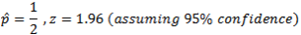
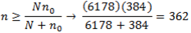

Response Data:

Number of respondents contacted: 362 (1st and 2nd batch)
Number of respondents: 76 (1st batch), 61 (2nd batch)
Number of completed responses: , 61 (1st batch), 51 (2nd batch)
Response Rate: 21% (1st batch), 17% (2nd batch)
Note: There was no incentive offer for the participants in the second batch.
In all there’s reasonable representation across the groups, with CFA having relatively lower representation than the other groups. Possibly weighting will be required for the CFA group during analysis.

The questionnaire is relatively short, but still longer and more detailed than the Univ. of Minn. study’s. The first things we ask are demographic. For example, we want to know if they have a declared major or not and a question regarding their background (race and homeland). The variables of the content core gauges the individual’s attitude towards big/debated questions of political and economic philosophy such as the size of government and government welfare. The other variables gauge the person’s views towards the most controversial social issues such as abortion. A combination of these variables gives us a pretty informative picture of the individual in our sample.

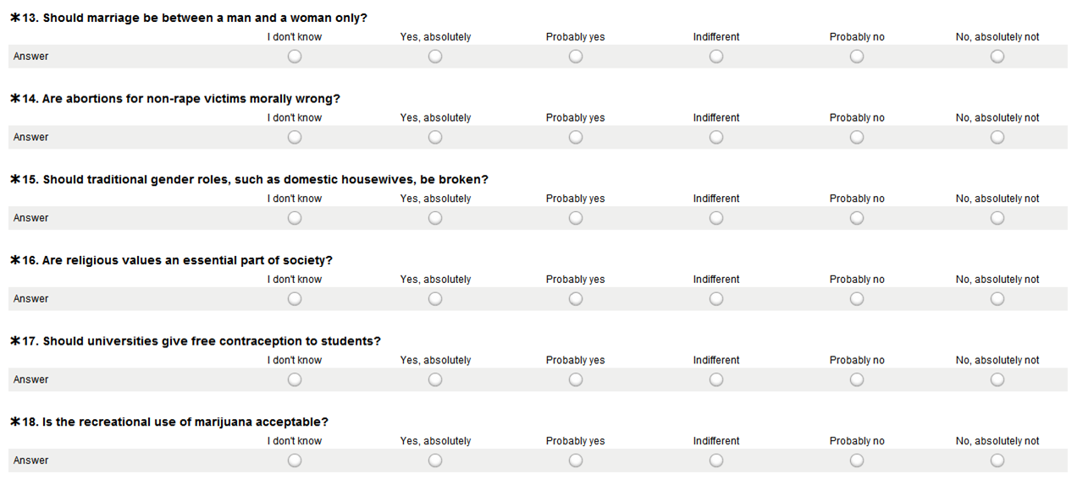

Section 3

Upon writing this rough draft, we have just about finished our survey window and will soon terminate data collection. Over the next few days we will codify our responses and organise our data for processing. Once the data is organised, we will proceed with the analysis. At this point, our only results regard response statistics and representation.

Appendix

Full Questionnaire:

Demographic

1. What is your grade level?
Freshman/Sophomore/Junior/Senior
2. What is your primary major if any?
Fill in
3. In which country have you spent most of your life in? If in the US, please specify your state.
Fill in
4. What is your race?
White/Black/Hispanic/American Indian/Asian/Pacific Islander /Other

Answering scheme for all questions:
(I don’t know)/(Yes, absolutely)/(Yes probably)/(indifferent)/(probably no)/(no, absolutely not)

Economic Attitude

5. Is government intervention in the business sector via regulations and monetary stimuli justified outside a recession?
6. Is a progressive tax based on income, where the wealthy members of society pay the most, justified?
7. Should trade with foreign nations be restricted in order to protect businesses and workers at home?
8. Do the poorest members of society deserve economic support?
9. Should more goods be made in America even if it means paying higher prices for them?
10. Is government spending on public goods justified (e.g. roads, parks, bridges)?
11. Should the US K-12 public education system be run as a business?

Social Attitude

12. Should marriage be between a man and a woman only?
13. Are abortions for non-rape victims morally wrong?
14. Should traditional gender roles, such as domestic housewives, be broken?
15. Are religious values an integral part of society?
16. Should universities give free contraception to students?
17. Is the recreational use of marijuana acceptable?
18. Is racial profiling for the sake of security sometimes justified by law enforcement?

Political Attitude

19. Is it justified to sacrifice liberty for security in a national security crisis?
20. Is larger government more effective?
21. Should governmental regulation of firearms be stricter?
22. Should the size of the military be reduced?
23. Are people adequately represented by their government?
24. Should taxpayer money be sent for the economic development of 3rd world countries?
25. Should burning your national flag be considered a crime?

26. Where do you stand on social issues?
Left/Centre-Left/Centre/Centre-Right/Right
27. Where do you stand on economic issues?
Left/Centre-Left/Centre/Centre-Right/Right
28. Where do you stand on political issues?
Left/Centre-Left/Centre/Centre-Right/Right

Contact Email:
---------------------
Hello!
You have been randomly selected to take part in this survey from the
official Student Directory. We are undergraduate statisticians conducting
a research project for 36-303 (Sampling, Surveys, and Society). Our
project concerns the relationship between academic major and political
attitudes. We kindly ask for your participation. The survey should only
take you about 10 minutes. You can find the link to the survey below:
https://www.surveymonkey.com/s/KHHCP7L
We appreciate your time!
We ask that you do not respond to this email. Thanks.

---------------------

Informed Consent Form:

---------------------
This survey aims at gauging the relationship between a student’s political attitudes and academic major. The survey is 28 questions long regarding different political, economic, and social issues. The survey takes approximately 10 minutes. The questions in this survey are mild;
however, some people may find some questions to be a bit sensitive. Your name or any personal identifiers will not be collected. If you have any questions or concerns please contact mtv@andrew.cmu.edu or mmusaeli@andrew.cmu.edu. Participation in this survey is completely voluntary and discontinuation of the survey can be done at any time.
---------------------

