ADVICE COLUMNS IN SOUTH AFRICAN PRINT PUBLICATIONS

By Mandi Chikombero and Mthetho
Tshemese

Table of Contents
Introduction 3
Rationale & Significance 4
Methodology 5
Sample 5
Analysis 8
Results 9
Discussion & Recommendations 14
Inherent Limitations of Advice Columns 14
Gaps in Advice 15
Recommendations for Columnists 15
Conclusion 16
References 18

ADVICE COLUMNS IN SOUTH AFRICAN PRINT PUBLICATIONS
INTRODUCTION
Although much is being done at national level to prevent and alleviate the impact of HIV and AIDS in South Africa, and although evidence suggests a decline in HIV prevalence among young people, general prevalence is still unacceptably high. According to UNAIDS, an estimated 5.7 million people are living with HIV. Of this about 3.2 million are women and 280 000 are children under the age of 14 years. As in other sub-Saharan countries, there are biological, social, cultural, and economic explanations for the gender differences in HIV infection in South Africa. Much remains to be done to prevent new infections. Recent evidence suggests that HIV rates are high in South Africa due in part to people having multiple concurrent partners (MCP) i.e., more than one sexual partner at the same time with the partners possibly overlapping for weeks, months or years. As Halperin and Epstein (2004) noted,
In Africa men and women often have more than one – typically two or perhaps three – concurrent partnerships that can overlap for months or years. This pattern differs from that of the serial monogamy more common in the West, or the one-off casual and commercial sexual encounters that occur everywhere. (p.4)
In the southern Africa region, more people are involved with multiple concurrent partners than anywhere else. Multiple concurrent partnerships take many forms including (a) steady partners and other ‘side’ partners, (b) intergenerational or age-disparate sexual relationships, (c) transactional sexual relationships, and (d) polygamy. In each case, a number of reasons have been identified for engaging in multiple concurrent partnerships including dissatisfaction in relationships, cultural/social norms, the need for money or other material possessions, and the influence of alcohol.
To date, communication has played a central role in the national prevention agenda. The role of communication has extended beyond merely transmitting preventive information such as correct and consistent condom use, but also to encouraging communities to communicate about HIV and AIDS and related issues. In this latter role (and with particular emphasis on MCP), the One Love regional campaign has been an enabling factor. Using mass media, social mobilization and advocacy to target the general population, the campaign aims to raise awareness of the risks of multiple and concurrent partnerships, to stimulate debate about how culture and gender impact HIV and AIDS, and to challenge cultural values that put people at risk.
It is in this context that the current study is taking place. The purpose of the study is to analyze if and how HIV and AIDS are addressed in responses to reader problems in ‘Agony Aunt’ or Advice Columns in 8 high-circulation South African magazines and 3 weekly newspapers.
Specifically, these are columns that were published between January and March 2009. The study seeks to understand if people are given informed HIV and AIDS advice along with other advice (e.g., emotional advice) the advice columnists give them. The study also has practical significance in that recommendations for including HIV and AIDS-related advice will be shared with advice columnists. Numerous researchers have documented the importance and pervasiveness of mass media in people’s lives. In fact, some argue that we are living in a ‘mediated world’ in which our experiences cannot be separated from the media. Concerning health issues such as HIV and AIDS, media play an important role with regards to what is discussed (agenda setting) and how it is understood/known. Many people rely on media for health information.
RATIONALE & SIGNIFICANCE
In South Africa, many people consult advice columnists about unfaithful partners and other crises relating to MCP. This is not a situation unique to South Africa. The ‘Agony Aunt’ has long been a feature of various media around the world including radio, print, and more recently the Internet. For hundreds of years now Agony Aunts have been assisting people to solve personal dilemmas. As Hendley (1977) noted, they serve the dual purpose of advising the desperate and entertaining the curious. Some Agony Aunts (e.g., Amy Dickinson of the ‘Ask Amy’ Column, Judith Martin aka ‘Miss Manners’, and closer to home, Criselda Kananda) have achieved celebrity status.
Interestingly, some agony aunts are fictional e.g., Abigail Van Buren of ‘Dear Abby’. This has not deterred ‘Dear Abby’ from becoming one of the world’s most famous advice columns.
Although traditionally targeted at women, increasingly there is an emergence of advice columns targeting men. Typically advice columns give advice relating to sex and relationships although some cover other health issues, financial issues, nutrition and general self-improvement. They usually take the form of a question (problem) and answer (solution) although sometimes there are visual images (such as illustrations or photographs) demonstrating the problems. The advice in these columns ranges from medical to social. Whatever form or focus they take, there is little doubt about the popularity of advice columns, resulting in part from the anonymity they provide. Researchers have suggested that readers of advice columns use them as a way to ask the same questions about their own lives.
Much research has been done tracing the evolution of the Agony Aunt service as well as assessing the value or contributions of Agony Aunts (e.g., Sirin, 2008; DeCapua & Findlay Dumhan, 2007; Boynton, 2007; 2004; Locher & Hoffmann, 2006; Currie, 2001). This research however has been confined to the study of advice columnists in Western societies. Consequently, no empirical research exists that looks at the role of advice columnists in addressing issues and crises unique to specific contexts such as HIV and AIDS or MCP in non-Western societies. It is important to study advice columns because like other cultural artifacts, they offer a glimpse into society’s prevailing values. They cannot be studied in isolation from topical concerns. In the case of South Africa, these concerns include HIV and AIDS and MCP.
Considering the four basic functions of media in any society (i.e., to inform, to educate, to entertain, and to facilitate social change), it is now widely understood that the mass media have a major responsibility in disseminating accurate information. In a context of high HIV prevalence, media have the added responsibility of giving preventive and life-saving information. In light of this, the following research questions guided this study:
RQ1: What relationship problems do people write about? Are the relationship problems that people write about related to MCP?
RQ2: What relationship advice do people get? Is HIV mentioned in the advice about MCP?
RQ3: Do people get HIV-specific relationship advice? This includes advice to leave multiple concurrent partnerships, have safe sex, or get tested
METHODOLOGY
Sample
Magazine and newspaper columns (n = 13) were selected for this study because magazines and newspapers are a popular inexpensive medium. In addition, because they do not require a high level of literacy, and because they have wide appeal due to the range of interests they cover, they have wide circulation. Finally, they are more ‘permanent’ than other media. Simply put, this means that they last longer – people lend each other copies and (in the case of magazines) they can be found in waiting rooms and reception areas for extended periods of time.
Eight high-circulation magazines were selected for this study, representing a balance in readership across gender and race:
- Bona – Bona is one of South Africa’s most read monthly magazine with a diverse scope including fashion, beauty, careers, cooking, parenting, and legal advice. Bona is published in English, seSotho, isiXhosa, and isiZulu. Bona’s reach extends into Namibia and Botswana. It is targeted at a black, largely female readership. Bona’s advice column is titled ‘Ask Sis Sarah’. For this study 12 letters were published during the January to March 2009 timeframe.
- Cosmopolitan – Cosmopolitan is one of the most successful magazines in South Africa. Its catchy tagline of ‘Fun, Fearless, Female’ appeals to its large body of readers. The magazine covers famous events around the world and aims to empower women. The advice column ‘Irma on Life and Love’ featured 12 letters between January and March that are analyzed in this study.
- Drum – Beginning in 1951, Drum has been called “the first black lifestyle magazine in Africa”. Drum enjoys wide readership and has become something of a staple in Black South Africans’ daily lives. It features market news, entertainment and feature articles. Drum’s advice column is ‘Dear Dolly’. When this column was started a popular actress and singer, Dolly Rathebe, wrote it. Today, however, today other Drum writers write it. For this study, 62 ‘Dear Dolly’ letters were analyzed. In addition to the ‘Dear Dolly’ column, Drum offers the ‘Testo-therapy with Bra Lucas’ column that is geared towards male readers of Drum. For this study, 10 letters from this second column were used.
- Fair Lady – Fair Lady’s website notes that the magazine is ‘100% original; an organic South African Brand’. The magazine views itself as being relevant to the modern South African woman and asserts this relevance in its tagline ‘Connect, Support, Celebrate’. Fair Lady remains current with global trends and aims to create a network of women who are shaping South Africa’s future. Its advice column ‘Fair Hearing with Erica Paul’ tackles social problems. In this study, 3 letters were used. The advice column aims to give an in depth response to reader letters and therefore only one letter per issue is published.
- FHM – FHM (For Him Magazine) is an international monthly men’s magazine. In South Africa, FHM is the leading men’s magazine. FHM presents relevant, sexy, and funny information for men. The advice column ‘Dear Dominika’ provided 6 letters for this analysis.
- Move! – Move! Enjoys a large readership among women in South Africa. The magazine features two advice columns. The first is ‘Sis Anne’ which addresses readers’ social problems. 20 letters from this column were used in this study. The second column, ‘Dr. Eve’ focuses on health problems. This column provided 10 letters for analysis.
- ‘O: The Oprah Magazine’ – Launched in 2002 as the first international edition of the ‘O’ magazine, the South African edition focuses on healthy living. It features articles on health, fitness, food, home and garden, travel, financial matters, and emotional wellbeing. The advice column ‘Dr. Phil’ addresses personal, social, and emotional problems. For this study, 4 letters were used.
- Real – According to the magazine’s website, Real is geared towards a black, largely female readership. Real provides an advice column ‘Advice from Melody Ngcuka’ which provided 8 letters for our analysis. Real has an additional advice column ‘Advice from Criselda Kananda’ which is provided for HIV positive readers and addresses the realities of living positively with HIV. This column was not used in this study.
Three newspapers were selected for this study:
- The Sunday Sun – Established in 2002, The Sunday Sun is considered one of the fastest growing newspapers in the country. Its content is mainly of a tabloid nature and appeals to largely black readers. It has expanded its readership to Botswana, Lesotho, and Swaziland. The advice column ‘Sun Health with Dr. Pinkie Ndaba’ provided 21 letters for this review.
- The Sunday World – The Sunday World is a tabloid aimed mainly at Black readers. It is distributed nationally and includes the column ‘Sista B’ which provided 21 letters for our analysis. This column appeals to female readers and tackles readers’ social problems.
- The Star – The Star is a daily publication with a large readership. It covers local news, sports, business, and community events and appeals to a racially diverse audience. It includes the column ‘Momma’s Bosom’ which addresses various social problems. 19 letters from ‘Momma’s Bosom’ were included in this study.
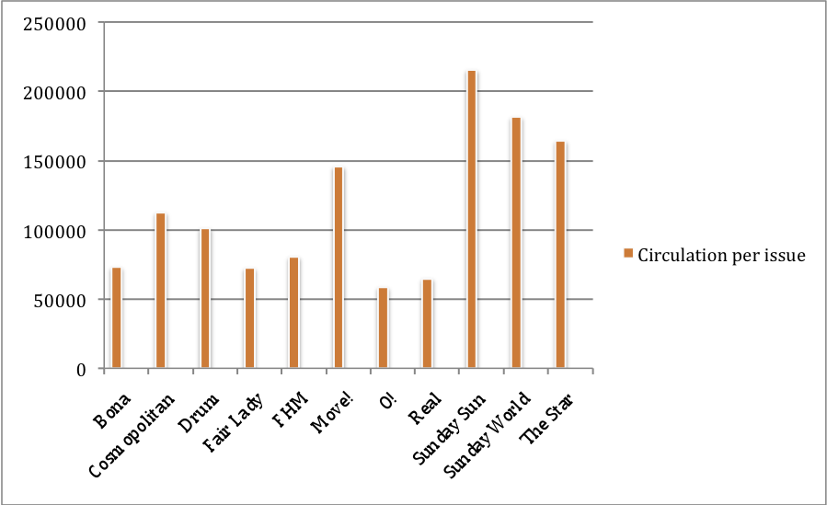
Letters (n = 215) and responses (n = 215) were selected over a period of three months between January and March 2009. It was important to capture print publications that were published during the time that the One Love campaign was starting. In South Africa the campaign was launched in January amid intense media coverage. The media environment at this time included prominent HIV and AIDS messages via radio, TV drama, and community dialogue sessions. Importantly, the campaign was endorsed and supported by then health minister, Barbra Hogan.

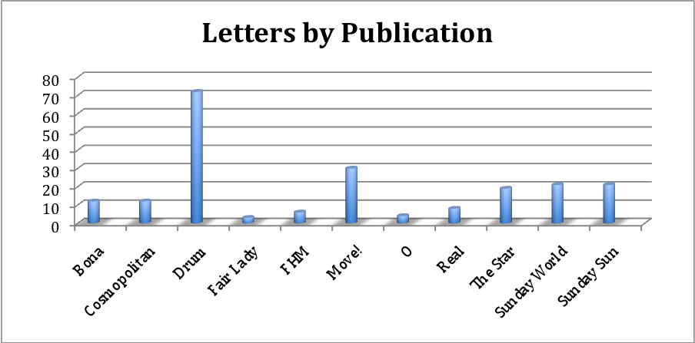
Analysis
The units of analysis were the letter and the response. These were treated separately in order to address the research questions i.e., in order to determine the kinds of problems that people write about and the kind of advice they get for those problems. Letters and responses were read inductively to begin with. All were read and re-read to discover repeated ideas and themes. These themes were checked against previous research and practice that shows their importance as they relate to HIV and AIDS. Later readings were a more systematic thematic content analysis (including descriptive statistics to determine frequency). Thematic content analysis involves examining the content of media to identify pre-determined themes. Specifically we tried to identify letters (problems) relating to HIV and AIDS risk. HIV and AIDS-related issues were pre-determined to include MCP, infidelity, unprotected sex, and promiscuity. We expected that the responses (advice) would include mention of the risks of HIV infection, advice to get tested for HIV, reducing MCP, leaving cheating partners, and use of condoms. In addition to this analysis, in order to determine useful suggestions to give columnists, open coding was done on the responses (advice). The coding process included both manifest (explicitly stated) and latent (unstated or less obvious) content.

PREDETERMINED THEMES
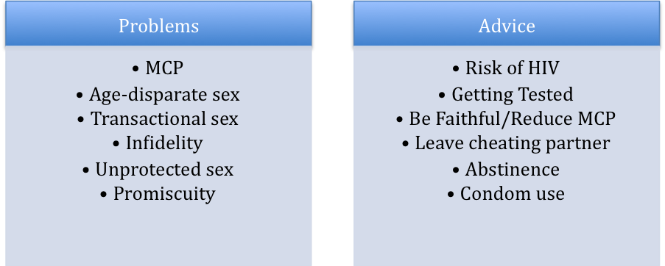
RESULTS
Demographically, women writers (n = 115) outnumbered men (n =61). The age range for writers was 13-61 with average age being 26.12. However, not all writers disclosed their age or sex in their letters.
The first research question (RQ1) asked about the kinds of problems readers wrote about and whether these problems were related to MCP. Letters revealed a range of problems. These problems were categorized into eight groups namely (a) issues to do with romantic relationships (n = 90);(b) issues to do with multiple concurrent partnerships (n = 45); (c) sexual issues (n = 36); (d) health/psychological issues (n = 20);(e) HIV-specific issues (n = 11); (f) family issues (n = 16); (g) body image issues (n = 7); and (h) professional advice (n = 3). It is important to highlight however, that a few of the problems were cross cutting and fell into two or more categories. A few letters could not be categorized (e.g., a letter from someone who was missing an old friend, and a roommate who suspected that her roommate was a prostitute). An example of a problem dealing with romantic relationships follows:
I’ve been with my boyfriend for a year and don’t know how he feels about me. He doesn’t like talking about feelings and rarely says ‘Me too’ when I tell him I love him. Also, he’s a flirt and has lots of female friends, most of whom he has slept with. He watches a lot of porn, which I hate, and he’s never in the mood to do anything with me, no matter how hard I try. I’m stuck. (Cosmopolitan)
The letters below demonstrate sexual problems:
My girlfriend can’t orgasm. I’ve never had this problem before; the girls I’ve dated always climaxed more than once in a session. We’ve been dating for more than a year now and I’ve tried everything! She says she wants to visit a sexologist. Please help! (FHM)
I’m very, very large and have a hard time pleasing her sexually because it hurts her when we have intercourse. What do I do? (Drum)
Of the letters pertaining to sexual problems, 50% had to do with sexual dissatisfaction (e.g., lack of orgasm, early orgasm, orgasm taking too long, over-lubrication, penile size, etc.). This is important to highlight as one of the most commonly cited reasons for engaging in MCP is sexual dissatisfaction.
The letters below contain HIV-specific problems:
I met this girl and I love her so much. I’m 19 years old and she is 17 years old. I have never been in love before. She has just told me that she is HIV-positive. What must I do? We are very young. (Move!)
I’m a 29-year-old woman in love with a 35-year-old man. We’ve been together for eight years. It happened that we broke up and I met someone else and got pregnant. When I was three months pregnant, I broke up with the guy and got back together with my ex-boyfriend. All was well until after I delivered the baby. The baby and I were both healthy, so our love became stronger each day. He then infected me with HIV-Aids (sic) and went and married someone else. The painful thing is that I still love him. He doesn’t even mention it to me that he is married. What should I do? Please advise. (Sunday World)

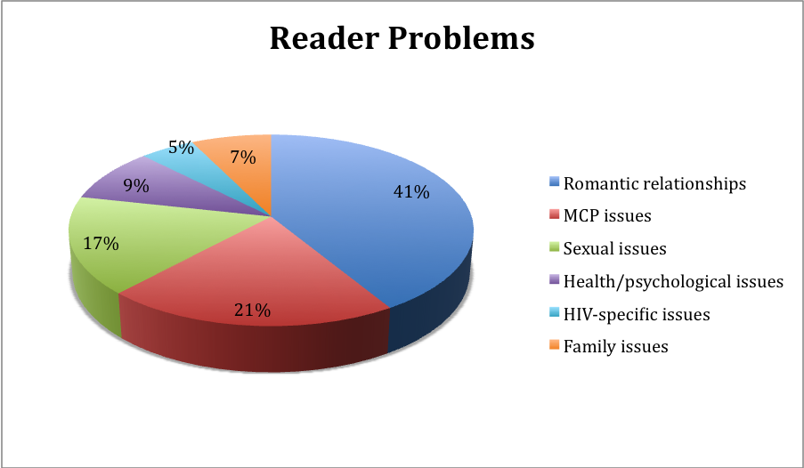

Even though HIV-specific issues account only for 5% of reader problems the HIV risk is higher than the 5% when one considers the MCP issues (21% of reader problems). Issues to do with MCP (age-disparate sex and transactional sex) were common as illustrated in the examples below:
I’m a 25-year-old lady with two boyfriends. I know this is wrong but the problem is I am spending more time with number two rather than the main one, number one, and I have fallen in love with number two. Now I do not know who to choose as they both love me and I do not want to lose either of them. Number two has a girlfriend and I know that I am not sharing number one with anybody. I really do not know what to do. (Sunday World)
I’m a 22-year-old mother in love with a guy who’s 24. We work together and I’ve been his mistress since the beginning of last year. Last September he told me his girlfriend had had a miscarriage and that he was dumping her for me. It was the moment I’d been waiting for and I believed every word he said. Now it appears he lives with a 30-year-old sex worker. When I confronted him, he said he was using her to get money. My feeling is there are more lies to come. Should I believe him when he says I’m the one he truly loves? (Drum)
I have been seeing a married man since March 2008, but there are times when I feel guilty and bad for his wife. I’ve also realized that I don’t think I’d like to marry this man. I know he cheated on his wife, so he’s capable of cheating on me. I’m confused as to what I should do. Should I go on with this affair or end it? I do love him and have feelings for him, but after nearly a year, is this what I want? (Bona)
Interestingly of the 45 letters relating to MCP, 29 (64,%) were from women. Of these 24 (53.3%) were from women whose spouses were cheating. The remaining five (11%) were from women who were cheating on their spouses. This pattern supports findings from earlier research demonstrating that women often find themselves being cheated on. This reflects socio-cultural norms around male infidelity and women’s positions in relationships.
Research questions 2 and 3 investigated the advice that people get and whether or not this advice, where relevant, is HIV-specific. For problems concerning HIV and MCP-related issues, about 48% of the advice given was HIV-specific. This means that the columnist gave advice pertaining to the risks of HIV infection or advice encouraging the prevention of HIV (such as leaving a cheating partner, getting tested for HIV, or discontinuing MCP). The rest of the advice given is such cases was not HIV-specific. To illustrate, the following two examples are of letters and advice (italicized) that is HIV-specific:

I’m a 25-year-old woman and I started dating my boyfriend in September. We started having lots of sex and during one of our love-making sessions, a condom broke. My sister then met my boyfriend and she says he looks sick cause he’s too skinny. Now I’m so scared. I’m also paranoid and even have nightmares about his status. I did my test before we started sleeping together. He had suggested that we go and do our tests together but we never did. What should I do? Please help.
A person doesn’t have to look unhealthy or have a bad smell to convince you to go for your HIV test. Checking your status should be the first thing you do when you get into a relationship. You’re not only checking for HIV-Aids (sic) but for other sexually transmitted diseases as well. So, without judging your boyfriend both of you must go and test. Remember to check again after three months. (Sunday World)
I’m 31 and HIV–positive, but my lover is not. We want to have a baby. Is this going to be possible for us, and where can we find a doctor who is willing to help us with artificial insemination? I don’t want my baby to be infected with HIV. What should we do?
This is a very brave decision you and your lover have made, but I’d still like to remind you of some of the facts, even if you have already considered them. About one in every three babies born to HIV-positive mothers will be HIV-positive if the mother and baby do not take an ARV like Nevirapine to stop this from happening. Babies born HIV-positive get sick very often, and usually die when they’re very small. If the mother is HIV-positive and falls pregnant, she may get sick with AIDS more quickly. Another point to consider: is your lover always going to be around to support you, irrespective of the outcome? There are many doctors who deal with artificial insemination. Your clinic sister or GP should be able to refer you to one. He will also be able to advise you and answer any questions you might have. (Drum)
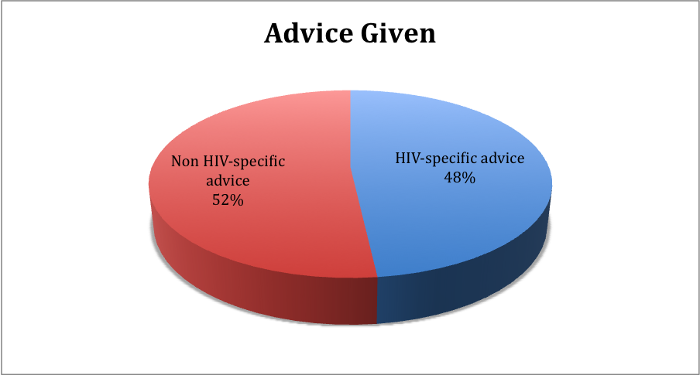
Other advice however, was not as HIV-specific (despite the problem being HIV and/or MCP-related) as demonstrated by the examples below:
I’m a 46-year-old woman and I’m dating a 60-year-old married man. His wife is 57 years old. I’ve been dating this married man for almost 20 years. During that period, I got married and my husband passed away. I then continued with the affair. He wants to be accepted into my family but his wife will hear nothing of it. When he talks with his wife about taking me as a second wife, she threatens him with divorce. He says he can’t lose me after having been with me for such a long time. Even worse is that their sex life is not exciting. We love each other but this whole thing is taking it’s (sic) toll on me. He keeps promising that things will get better but they don’t. I’m afraid of getting a new man because of this HIV-Aids (sic) scare.
I cannot condone the practice of dating married men. I understand you’ve gotten used to this way of life but it’s wrong and nothing will make it right. I can only imagine the tight corner you two women have pushed this man into. I wonder how you would feel if you were his wife and he was taking his mistress as the second wife? Or if he took a third wife after you, someone much younger than you? It seems your married sweetheart is not ready to leave his wife. So don’t try to destroy what God has put together. (Sunday World)
I found out that my husband was cheating on me with two women. When I confronted him he got angry. I forgave him because I love him. Now he wants a divorce. He says I don’t treat him well, I’m stingy and we have no future. I love him and I don’t believe in divorce. What should I do?
It seems you are a humble and honest person. Keep on trying to resolve matters and perhaps involve family members – but if he’s not a good man, he’ll leave you no matter what you do or say. (Sunday World)
A number of MCP issues are present in the above examples. For instance, the reader problems demonstrate age-disparate relationships and concurrent relationships. In addition, the issue of sexual dissatisfaction highlighted in the first problem is a common reason for engaging in MCP. However, the advice given does not allude to these issues. Nor does it frame the problems in terms of HIV risk.
In some cases, the advice given included communicating with a cheating spouse or forgiving infidelity, placing the person at risk of continuing in a relationship where she is at risk of HIV (The Star). In other cases, the advice given was irresponsible. In a case where a reader wrote in confessing to cheating with a man who in turn was in a relationship with someone else, the columnist responded: “…you and the …boyfriend are birds of a feather, so you should stick together” (Sunday World). This can be viewed as encouraging MCP without discussing the risks. In addition some of the advice that was given was moralizing and blaming. In response to a letter from a reader who was thinking of leaving her boyfriend as the romance had fizzled out and she had met someone else, the advice columnist responded: “I think you’re crazy to break up with someone you’ve been with through thick and thin…’ (Drum). Similarly a reader wrote in because he had engaged in oral sex with a girl who had a cold sore and now he had a sore on his penis. The advice columnist responded, “ You chose to do it, knowing you were at risk for an infection”. In a final example, a married woman wrote in confessing that she had fallen in love with a co-worker and was wondering what to do. The response she received from the columnist was, “You’ve committed adultery just by imagining. Don’t take it any further. You might not believe me, but this is infatuation. Don’t allow it to destroy your family and don’t act like a tramp” (Sunday World). Such advice represents missed opportunities to inform readers of the risks of HIV infection.
DISCUSSION & RECOMMENDATIONS
This study was limited in that it focused on only one medium of communication – the advice column in print. This is a significant limitation because although the publications under study have wide circulation, they do not reach the majority of the South African population. A different medium (such as radio) may have wider reach.
Inherent limitations of advice columns
Advice columns themselves present a number of inherent limitations including:
- Lack of human connection and interaction - Columnists cannot access non-verbal communication and cannot clarify the history or contents of the problems. In a sense, they are given advice in a vacuum or artificially neutral context. Although this is part of the appeal of the advice columns readers who write in with their problems, it presents some serious limitations for columnists.
- Limited time and space – The letters that appear in print are oftentimes edited. This raises the question of whether enough content remains to understand the problems that writers express. Also it is not clear how much time columnists spend dissecting readers’ problems before responding.
- Real vs. ‘fictional’ columnists (e.g. ‘Momma’s Bosom’) – Some columnists are ‘fictional’ in the sense that there is no single person behind the column but instead a number of writers, some even of a different sex than the title of the columns suggests! This presents a challenge in terms of understanding the emphasis of the column and whether or not readers and writers know this.
- Ethical responsibility not guaranteed – It is not clear what ethical responsibilities columns have. If they are presented to readers mainly for entertainment value, what responsibilities does this entail?
- Uncertainty about the framework of some columnists – With the exception of a few columns such as ‘Dear Dominika’ and ‘Testo-therapy with Bra Lucas’ that are seemingly skewed towards giving advice on sex and pleasure for men, the frameworks that columnists operate from are not always readily apparent. However, these frameworks influence the advice that they give.
- No feedback from or follow up with readers – There is no indication that writers write back after receiving feedback to give a follow-up. There is therefore no easy way of finding out whether or not columnists’ advice was taken up and with what effects.
Despite these limitations, the findings of this research are informative and have important implications. They show that people need advice on a range of different problems. However, pertaining to HIV and AIDS issues, readers write in with relationship problems including the full range of MCP, i.e., infidelity, age-disparate sex, polygamy, and transactional sex. Similar to previous MCP research reasons given for MCP include sexual dissatisfaction in steady relationships and the need for money and other material possessions.
Gaps in Advice
The findings suggest some huge gaps in advice in a country with the largest HIV epidemic in the world. These gaps relate to the perceived functions of media in society, particularly educating the public and facilitating social change. For example, some of the advice that is given does not speak directly to the risks of MCP. This may be because columnists may not know how to frame issues of MCP as an HIV risk, or they themselves do not know the risks.
Overwhelmingly the focus of the advice is emotional encouragement rather than proactively preventing HIV. In the South African context, this is a serious shortcoming given findings from research and practice demonstrating the risk involved. In addition, research has documented that declines in HIV prevention are associated with reductions in numbers of sex partners (Green et al., 2009). The findings of this study suggest that people need advice that emphasizes risk of HIV infection. For example research shows that condoms are rarely used in sexual relationships involving girls and older men (Gregson et al., 2002). Yet, advice given regarding such problems does not emphasize this.
More often than not, women are the ones in relationships with cheating partners. Such dynamics are best understood in the context of gender and culture in South Africa. As Leclerc-Madlala (2009) notes, it is important to understand and address “the cultural milieu in which sexual partnering practices are located and reproduced” (p. 103). In a study of MCP in southern Africa, Leclerc-Madlala found that southern African societies have preserved several cultural scripts that affirm MCP and lend “cultural legitimacy” to MCP (2009). It is therefore important that advice columnists understand these issues in order to give useful advice. It is clear that “there needs to be franker discussion . . . addressing the dangers of having more than one long-term sexual partner at a time” (Halperin & Epstein, 2004).
Recommendations for Columnists
Recognize that South Africa is in the throes of a very serious HIV epidemic. Every column that deals with sex and relationships needs to ensure that HIV is given top priority when exploring the issues presented in reader letters. Given how serious the epidemic is in South Africa, HIV should be the first thing that comes to columnists’ minds when they are faced with letters about issues such as infidelity or MCP
Provide readers with contact information for further resources. In some cases, advice columnists can best help readers by sharing information on community resources that readers can utilize such as local organizations that can best assist people. ‘Momma’s Bosom’ has contact numbers for other health institutions. Perhaps other columnists and publications can adopt this and even expand the scope of giving contact details of useful organizations.
Avoid moralizing and blame. Further, advice needs to be given in a non-moralizing and non-blaming way. In many cases however, this is not the case. Columnists must ensure that they handle reader problems in a sensitive manner.
Set Criteria for good advice. Perhaps it is useful for the publications to agree on criteria for good advice and get up to date information on HIV and AIDS.
Columnists should equip themselves with information on MCP and associated risks. In order to give effective advice, columnists should be aware of issues such as MCP and the heightened HIV risk MCP presents in order to give sound effective advice where relevant.
Balance entertainment with information. In spite of the entertainment value that advice columns provide, readers do expect advice that can help them solve their problems. There is therefore a responsibility on the part of columnists and publications to provide informed advice.
Given that the study covered only three months of the columns it may be useful to do a more comprehensive and longer study on advice columns to see if the picture will be similar or different. It is hoped that by equipping columnists with information on HIV and AIDS they will be consistent in the advice they give and will ensure that they improve their ethical considerations.
CONCLUSION
It is important to acknowledge the importance of the persona of the columnists and the influence it has on the kinds of letters they receive as well as the kinds of advice they give or are expected to give. It is clear that the advice columns provide entertainment value, particularly in the case of popular magazines. This is evident in the style of advice giving in some of the publications (for example the brash and sassy ‘Sista B’ column). It is also evident in illustrations of reader problems in some cases (e.g., ‘Momma’s Bosom’). The titles of the column (e.g., ‘Fair Hearing’, ‘Testo-Therapy with Bra Lucas’) allude to the expected role (and advice) that the columns provide.
Given the HIV and AIDS context in South Africa, this study investigated whether lifesaving information is being given. In a sense this study is taking advice columns more seriously perhaps than casual readers would. It is also suggesting that columnists take them seriously in terms of the kind of advice they give. Clearly, people expect useful advice. Such advice need not be given in a serious manner at all times but it must be given. The role of media in the middle of an epidemic must be to inform and to facilitate positive social change. This study revealed a number of missed opportunities to discuss the very real risks of HIV infection (such as MCP) that reader letters display. As columnists give advice on relationships, sex and sexuality they must always be mindful of the debates around gender, culture, and the broader context in which these relationships take place. Doing so will ensure that they fulfill their mandate as public communicators to inform, educate, entertain, and facilitate social change.



REFERENCES
Boynton, P. M. (2007). Advice for sex advisors: A guide for ‘agony aunts’, relationship therapists and sex educators who want to work with the media. Sex education, 7(3), 309-326.
Currie, D. (2001). Dear Abby: Advice pages as a site for the operation of power. Feminist Theory, 2(3), 259-281.
DeCapua, A. & Findlay-Dunham, J. (2007). The pragmatics of advice giving: Cross- cultural perspectives. Intercultural Pragmatics, 4(3), 319-342.
Green, E., Mah, T., Ruark, A., & Hearst, N. (2009). A framework of sexual partnerships: Risks and implications for HIV prevention in Africa. Studies in Family Planning, 40(1), 63-70.
Gregson, S., Nyamukapa, C. A., Garnett, G. P., Mason, P. R., Zhuwau, T., Carael, M., & Chandiwana, S. K. (2002). Sexual mixing patterns and sex differentials in teenage exposure to HIV infection in rural Zimbabwe. Lancet, 359(9321), 1896-1903.
Halperin, D. T. & Epstein, H. (2004). Concurrent sexual partnerships help to explain Africa’s high HIV prevalence: Implications for prevention. Lancet, 364(9428), 4-6.
Leclerc-Madlala, S. (2009). Cultural scripts for multiple and concurrent partnerships in southern Africa: Why HIV prevention needs anthropology. Sex Health, 6(2), 103-110.
Locher, M. A. & Hoffmann, S. (2006). The emergence of the identity of a fictional expert advice-giver in an American Internet advice column. Text & Talk, 26(1), 69-106.
McKay, S. (2008). Advice columns as cultural intermediaries. Australian Journal of Communication, 35(3), 93-103.
Sirin, A. (2008). Self-disclosure through sharing with the public. Journal of Instructional Psychology, 35(3), 288-293.
Tankard, J. W. & Adelson, R. (1982). Mental health and marital information in three newspaper advice columns. Journalism Quarterly, 59(4), 592-587.

