Summary of performance on Exam 2, 36-303, Spring 2011

Here are some summary statistics on Exam 2 in our class:

> summary(exam02)
Min. 1st Qu. Median Mean 3rd Qu. Max. NA's
37.00 73.00 82.50 78.18 88.00 98.00 2.00

A histogram of the exam scores looks like this:
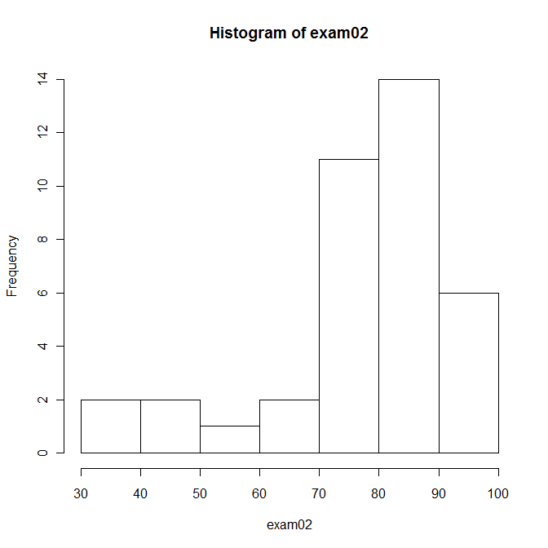
As indicated in the syllabus, if you participate in presenting your project as a poster at Meeting of the Minds, I will drop your lowest non-zero exam score. I was expecting this might produce some low scores on this exam, since it would not be necessary to put full effort into the exam in order to benefit from this policy. The scores of students who finished the exam in 1/2 hr or less ranged from under 40 points to over 85 points, so this turned out to be less of an issue than I expected (or, the exam was just too easy!).

I do not assign letter grades to exam scores in the gradebook, but to give you some guidance, if I did assign letter grades it would be like this:

Range Letter Number of Students
90-100 A 8
80-89 B 16
65-79 C 9
50-64 D 1
0-50 R 6

[of course, not all the R's are really R's because of the "drop exam for MotM" policy above.]

See you in class,

-BJ

