CMU Student Perceptions of Academic Integrity and Old Course-Materials Archives

Team A: Victoria Docherty, Will Ouyang, Daphne Tsatsoulis, Bin Yang

April 26, 2010

**Section 1: Introduction**

**Research Question and Motivation**

* 2. We set out to find out more about the awareness of Carnegie Mellon Undergraduate Students regarding the academic archives kept by Greek Organizations, and other campus organization. These academic archives included old class notes, projects, homework, and other materials. In addition, we wanted to find out if students had access to these materials and whether they were using them. Finally, we were interested in discovering if students believed the usage of these materials were ethical, with hope of evidence to push for a new official-sanctioned old course material system.
  3. With Carnegie Mellon University being a world-class institution known for its rigorous academics, we believed that it was important to find out whether the students here truly comprehend and knew all the academic policies on-campus. We hope, that by finding out about what students feel about old test and course material stockpiles, and their opinion on a possible solution, we could propose a new system for the entire campus backed with strong statistical backing to the university administration. This system would hopefully be a campus-wide, official university-sanctioned system of old academic materials for all classes to ensure all students to have the same advantage in achieving academic success.

1. **Citations to Relevant Literature – An Overview**
   1. CMU’s *The Tartan* published an article in late 2008 surveying members and leaders of Greek organizations, clarifying official CMU academic policies on the issue of old stockpiles, and referring to Case Western Reserve University’s approach. It can be found here: http://www.thetartan.org/2008/11/10/news/greeks
   2. The Journal of College Student Development also published an article about an examination involving academic dishonesty between sorority and non-sorority women. The article talks about the significant differences between the frequency of occurrence of academic dishonesty between Greek and non-Greek students, which helps to show a divide between the Greek and non-Greek student population. It can be found here: http://muse.jhu.edu/journals/journal_of_college_student_development/v048/48.6williams .html
   3. Case Western’s *The Observer* published an article in late 2007 reviewing the actions of the Academic Integrity Board there and highlighting the ambiguity of the issue. It can be found here: http://observer.case.edu/Archives/Volume_40/Issue_9/Story_2145/
   4. A good potential reference to the scale of the problem can likely be found by Case Western Reserve University’s statistics on how many students were investigated for academic dishonesty (essentially, how many were “caught” as opposed to the estimated percentage of students who have used questionable material before): http://studentaffairs.case.edu/groups/aiboard/statistics.html

**Quick Summary of Main Results**

After reaching our goal of 150 responses, we have been able to come to several general conclusions. Results show that informal social networking seems to be the largest source for old course archives, that many students do not consider using these materials to be cheating even though university policy may state otherwise. Lastly, students are generally receptive to the ideal creation of a university-wide system of public archives from old courses and do believe that such a system would be beneficial to them.

**Section 2: Methods**

**Target Population and Frame:**

The population we targeted for sampling is the undergraduate Carnegie Mellon population of 5705 students. In order to extract a random sample from this population we used a comprehensive list of undergraduates that was provided by Stafford Brunk, a fellow student in our class. Stafford Brunk wrote a Ruby script to compile a list of all names of undergraduates at Carnegie Mellon by using the online student directory.

Our random sample was selected by assigning a random number between 0 and 1 to every individual in our list of undergraduates. We then ordered the individuals numerically, from 0 to 1. From this list, we selected our subsamples, beginning with individual 1, and working our way down. In effect, we created a completely random listing of the undergraduates at Carnegie Mellon and selected a subset without bias.

**Sample Size:**

In order to calculate our sample size we used the formula presented in class:



As seen above, our confidence interval is 95% with a ±0.08 error rate. In order to be conservative, we selected a probability of 0.5.

The sample size we required for a ±0.08 error rate was 150 students.

**Sample Design and Methods:**

We decided to use Two-Phase Sampling in order to gauge our response rate before sending out the bulk of our emails. We initially sent out a request email with a link to our survey which was created using Survey Monkey. After a few days a reminder email was sent to the same group of students. In Phase II, we were also required to send out a second reminder email. All emails can be found in the appendix section of this paper.

In Phase I we sent out 150 emails requesting students to complete our survey, this first email had an 11% response rate. After about five days we sent a reminder email, and in this email we detailed that a $20 Starbucks gift card would be raffled off to those who took our survey. By the end of Phase I, we had 36 responses, which is a 24% response rate.

We used this response rate to determine the size of our Phase II subset. Of the required 150 responses, we had 36, and still needed 114. Based on a response rate of 0.24, we determined we needed to send a minimum of 475 Phase II emails. However, we felt this was too high of a response rate in relation to those discussed for email surveys in class. A 0.20 response rate would have required that we email 570 individuals; we decided to email 579 individuals in Phase II.

**Response:**

In the first phase of our survey we had contacted 136 students, and had a 24% response rate. In our second phasewe contacted 579 students, and had a response rate of 22.6%. Overall, 729 students were contacted, and of that, 22.9% (167 students) responded to our survey. However, only 150 of those students fully completed our survey, causing an item non-response rate of 10.2%.

We believe that the unit non-response rate was caused by various factors including: subject sensitivity, burden due to the length of the survey, and how applicable the survey was to each student. Our survey dealt with the very sensitive subject of student integrity, cheating, and the distribution of old course materials not known to professors. It also explicitly required students to admit if they obtained their materials from campus sororities or fraternities. We believe this was a major cause in both our unit and item non-response.

To illustrate the sensitive nature of our survey, we have listed the following questions:

* Did the possibility of having access to potential academic archives affect your choice to join a Greek Organization?

Yes/No

* What is the source of your access [to old class materials]?

Fraternity/Sorority CMU Student Organization Social Network

* Are you a member of a fraternity or sorority?

Yes/No

From these questions it is clear that students taking our survey would assume that their answers could implicate their Greek Organization.

One of the questions in our survey asks, “Do you think that Greek Organizations have archives of old class materials?”. We found that many students stopped taking our survey at this question, most likely due to the fact that they felt uncomfortable disclosing this information. Another point at which students stopped taking the survey was at the last page, when we asked about their demographics. We believe that students did not want to have their answers connected with any campus groups, such as Greek Organizations, certain majors, or years. The third point at which students stopped taking the survey was at the first page; our survey was very long and we feel that once students realized the length, they were not willing to continue.

Besides the avoidance a sensitive subject, we believe our item non-response was also due to the fact that some students did not feel that the survey applied to them. During our testing period we had various students in Drama and Architecture tell us that they do not take written exams, or have homework that can be replicated yearly. Therefore, our questions that asked about access and use of old exams and homework, did not apply at all to them. They felt that the survey would not reflect their major, and decided they could not take it.

**Post-Survey Processing:**

Our item non-response was not missing at random. We believe that students did not randomly decide to not take our survey, nor did any subgroups specifically refuse it. The survey directly asked students if they had access to materials that could incriminatethem. Cheating is a very serious matter at Carnegie Mellon and it is understandable that all students would be weary of answering such questions. For this reason, we chose not to impute our data. Any imputation would lead to bias because we did not know the reason for our non-response nor what the responses would have been based upon other demographic characteristics of the student.

For unit non-response we divided the responses amongst sex, year, and Greek affiliation. We had a disproportionately large number of sophomores as part of our sample (+9.1% compared to official CMU statistics) and too few seniors (-9.9%). In terms of gender, we also had about a 10% swing (too many female respondents) compared to the CMU population: 50.7% of our respondents were female, compared to a population proportion of 41%. This meant that males were underrepresented (49.3% versus 59% population) in our sample. The strongest reason why we were encouraged by our results and decided not to weight them was because our sample had an extremely accurate proportion of respondents who indicated membership in a social fraternity/sorority (23.3% versus 21% actual). Ultimately, we decided that any gender/class level distribution concerns were not very significant when considering that our survey deals heavily with sensitive material that involves the Greek community and student organizations as a whole.

**Section 3: Results**

**3.1: Introduction to Results**

*Restating our research questions and specifying the portion of the sample that we used*

The primary question that we wanted to answer was exactly how aware Carnegie Mellon undergraduates are of the usage of old academic materials versus university policies on such usage, and what student attitudes are towards such usage. We also wanted to know how such materials came into their hands and what student attitudes would be like for our proposed idea, a campus-wide academic archive where materials are submitted by professors. We were very aware of how sensitive these topics are and tried to make our questions as objective and direct as possible in order to try to account for potential student disinterest or cautiousness.

167 undergraduates started our survey, and 150 completed it (for a completion rate of 89.8%), and because we did not use post-stratification weighting, our results are based only on the 150 complete responses. Our margin of error is ± 8%. We are confident in the representativeness of our sample and therefore will generalize the results described below to the Carnegie Mellon undergraduate student body. Official statistics were obtained at the online Carnegie Mellon fact pages cited at the end of the paper ["Factbook: Enrollment" and "Fraternity and Sorority Life Report, Spring 2009”].

**3.2: General Results**

*Discussion of the individual results from selected survey questions and how it answers our research questions*

Overall, we found that 52% of CMU undergraduates have access to some type of old academic materials [Survey Page 2 Question 5]. When asked to indicate the source of access (with multiple sources allowed to be checked) [Survey Page 3 Question 1], we see that although we knew going into this project that fraternities and sororities are scrutinized for having old course materials, something as simple as the Frisbee club or the finance association seems to be equally likely to have provided you access to some kind of old academic material. Overall, informal social networks (example: friends) garnered 59 responses as opposed to 23 for student organizations and 21 for the Fraternity/Sorority option. We also had an “other” write-in option that showed we missed a few key sources of access, such as having personally taken a course before, discovering professors’ old websites, etc. A handful of our 36-303 classmates kindly informed us that they noticed as much when taking our survey, and our group does suspect that the “other” option has the effect of under representing how popular the aforementioned sources are. In terms of what materials students actually use out of everything that they possess, 51.3% of students indicated that they didn’t use old academic materials. Exams (51) were the most popular option checked (with multiple choices allowed), followed by Homework (41) and Notes (35).

Our survey indicated a strong student awareness of academic archives possessed by the Greek community and an intense belief in the advantages that possessing old academic materials may provide. Some members of our group are part of Greek fraternities and sororities, and we can also confirm as upperclassmen at CMU that in addition to these organizations, we know various clubs and networks of friends most certainly share old academic material with one another. Our results show that 75% of students believe that Greek organizations have academic archives [Survey Page 5 Question 1]. In addition, 89% of students think that possessing old academic materials in general provides an advantage [Survey Page 5 Question 6]. When specifying if the advantage provided by each type of academic material would be significant (specifically, change the letter grade achieved in the class), a clear distinction was observed between old exams (62%) and programs (44.7% but more important than it might seem because this option is only relevant for technical majors) versus old notes (14.67%) [Survey Page 4 Question 2].

When reviewing results such as the ones listed above, it might lead a casual observer to guess that students disapprove of the materials’ usage. However, in contrast to such a hypothesis, we found that when asked about the ethics of using each individual type/source of academic material, a large portion of students (often the majority) stated that they believed it was not cheating [Survey Page 5 Question 9]. In particular, 97.3% of students believe that utilizing classmates is not cheating and 92.7% believe that using students who took the class before is not cheating. One of the most stunning results was for the usage of old exams, which most people would say provides the biggest advantage: 58% of students believe that using old exams is not cheating. While this last result in particular has the value of 50% within our margin of error (± 8%), our overall results from this question show that very few types of old academic material usage are considered to be cheating by undergraduates.

All in all, 57% of students believe that having access to old academic materials is fair [Survey Page 5 Question 7]. Furthermore, it is perhaps not surprising, then, that most CMU undergraduates cannot correctly identify what university policy is toward possessing old materials of any kind. According to the article in *The Tartan* that we cited as part of the basis for our initial interest in this research topic, the Director of Student Life was quoted as saying that the usage of old academic materials is completely legitimate unless a professor explicitly states otherwise regarding sharing materials with other students, etc [“Stockpiles stir concern” p. 1]. When asked what the official university policy is on the usage of old materials given a range of plausible choices, our survey shows that over 73% of CMU students will either reply incorrectly or do not know.

Our results show a significant desire by undergraduates to have access to more academic materials. When asked who should ideally have access to old academic archives (assuming that they exist) [Survey Page 5 Question 8], 54% of students replied that everyone should have access as opposed to just 22% who did not think that anyone should have access. Finally, we have strong evidence of support for the creation of an officially sanctioned campus-wide academic archive that would be maintained by professors. 86% of students support the idea of such an academic archive [Survey Page 5 Question 10] and 72.7% believe they would benefit from one [Survey Page 5 Question 11], which are strong results even when adjusted by our margin of error.Our group believes that these specific results show a true longing by students for more old academic materials to work with while taking classes at Carnegie Mellon.

Although these general results demonstrate a low student awareness of official policies, surprising student attitudes and perceptions of what is fair, and strong support of a campus-wide academic archive among other conclusions, it is clear that further examination of our research questions in closer detail should be performed, and the results are in the next section.

**3.3: Statistical analyses**

*Detailed statistical analyses of selected questions, coding methodology, and how they answer research questions*

Several portions of this paper discuss or refer to the fact that our group ultimately decided that only a specific selection of the questions that we asked on our survey were necessary to answer our research question or merited further statistical analysis.

We selectively coded 15 survey questions to determine individual group means and potential relationships between pairs of questions. These questions and the coding procedure that we decided upon can be referenced in Appendix 1.

Our next step was to utilize the software package Minitab in order to conduct several one-way ANOVA tests (analysis of variance). Our primary goal was to test if the means of different groups (such as class level, Greek membership, etc) were equal. If they were not, then we would have evidence of specific relationships between group membership and how students answered the questions. The three key themes to our ANOVAs were based off of our research questions and included knowledge of academic policies, access to old academic materials, and support of a campus-wide archive.

The resulting output from Minitab is located in Appendix 2.

Our first test was to see if our conclusions about student knowledge of university academic policy regarding old materials were affected by class level (Appendix 2, ANOVA 1). We observed that sophomores answered the question correctly most consistently (33.3% were correct), followed by freshmen (22.2%), juniors (30%), and lastly seniors (15%). The observation that upperclassmen actually fared worse in their knowledge of academic policies shows that being an undergraduate at Carnegie Mellon for a longer period of time does not increase your awareness of the official university stance on old materials. In fact, it seems that more experienced students seem to be more confused about what the right answer is after having spent more time in classes and observing how their professors and classmates behave.

Next, we decided to test for the effect of being in a fraternity/sorority or other officially-recognized student organization and how that might affect the average CMU student’s ability to gain access to old academic materials. We discovered that 60% of Greeks had access to some type of old academic material versus 48.7% of unaffiliated students (Appendix 2, ANOVA 2).

By contrast, interestingly, those who are involved in an officially-recognized student organization are about 6.3% less likely to have access to old academic materials (Appendix 2, ANOVA 3). It should be noted that just over 61% of students said that they were involved in a student organization (excluding Greek life). When compared to ANOVA2, there is an implication that being in a Greek organization increases the probability that you have access to old materials, regardless of how involved you are in other ways such as through other student clubs, associations, etc. In fact, ANOVA 3 seems to show that involvement with student organizations might even slightly negatively impact a student’s access to old academic archives.

We followed up on our conclusions regarding support for a campus-wide academic archive by testing against academic achievement (QPA measurement) and class level. We discovered that while it is true that students who fall into the lowest QPA range have the highest support for this additional academic resource, high-achieving students are just as supportive, on average, as those on the lower end of the QPA spectrum. 87.7% of students with QPAs of 3.51-4.00 support the idea versus 88.9% of those in the lower range of 2.51-3.00 (Appendix 2, ANOVA 4).

With regard to the effect of class level, there is very solid support for the archive independent of how many years students have spent at Carnegie Mellon(Appendix 2, ANOVA 5). Specifically, freshmen support a campus-wide archive the most (over 94%), while support stays even at other class levels (about 82-85%). Thiscould provide support for our group’s educated guess that freshmen feel they have the least academic support, so when CMU spend more time after a few semesters, they find other ways (Greek life, student clubs, etc) to acquire the academic materials that they desire.

Our final portion of statistical analysis focused on more sensitive questions related to the Greek community and the effect of possessing of old academic archives. When asked whether or not the Greek community as a whole keeps old academic archives (Appendix 2, ANOVA 6), freshmen responded yes at the lowest rate (58.3%), with the level generally rising by class level to between 80 and 85% for upperclassmen. We followed this up by asking about whether or not one would join a fraternity/sorority assuming that these archives existed and comparing the results by class level again (Appendix 2, ANOVA 7). We found that that while only 8.3% of freshmen responded in the affirmative, 17.5% of juniors and 20% of seniors would join a fraternity or sorority in order to gain access to academic archives. This shows that the desire to go Greek because of access to old academic materials more than doubles by the time the average CMU student becomes an upperclassman. Our group finds these two analyses to be solid evidence in the observation of how undergraduates’ attitudes and perceptions toward Greek life change based on how many years they have spent at CMU. It should be noted that our 5th year (“Super seniors”) sample size of 3 respondents was deemed to be too small and therefore, we did make any conclusions about the CMU 5th year student population based on the results we obtained.

**3.4: Conclusions about our research questions**

Overall, our data seems to suggest that the university and/or faculty members could do well to adopt a more consistent, widely known stance on the usage of old academic course materials. Students of all class levels do not seem to understand what the existing policy is, and there is even some statistical evidence to the notion that upperclassmen are even more confused.

Undergraduates seem to be greatly aware of the academic archives that Greek fraternities and sororities, among other sources, possess. The great majority of students acquire such material through informal social networks. A great majority of students also believe that the usage of almost all types of old material is not cheating.

In addition, students overwhelmingly favor the establishment of an officially sanctioned academic archive. Although our description of such an archive in the actual survey is neither extensive nor detailed, our research has shown that Case Western Reserve University has already set a precedent by moving forward in such a direction [“Stockpiles stir concern” p. 2].

We would advise that if interested, the university should move forward with larger, more extensive student surveys (while protecting individual anonymity and minimizing the fear of retribution against the Greek community and student organizations) in addition to consulting with other universities on the prospect of experimenting with offering all undergraduates an archive of material with which to use for each semester’s classes.**Section 4: Discussion**

**Our Research Questions:**

Post-survey, we found that our research questions, which are:

1. Are Carnegie Mellon undergraduate students are aware of the academic archives kept by fraternities, sororities, and other campus organizations that may contain old class notes, exams, projects, and homework?   
 2. Do students not affiliated with such organizations have equal access or any access to those resources?  
3. Are these resources and archives used?  
 4. If used, is the use of these resources ethical (to students both in the organizations and outside of the organizations)?  
5. Would an officially-sanctioned old course materials system benefit the Carnegie Mellon academic undergraduate community?

turned out to be more sensitive than we had originally perceived. They were all answered within our survey because we had specifically designed the survey around these questions, to make analysis easier at the end. However, we did not realize that students would have a hard time answering them, not because they were difficult questions, but because the questions themselves made the respondents feel uneasy.

The question people probably had the most trouble with was question (4) because it specifically looks at people’s moral standards for themselves. We promised that results of the survey would remain confidential, yet participants still approached members of our research team, telling us that it was not our place to determine whether or not their “study rooms” were ethical, moral, etc. So perhaps our survey would have sparked less controversy or would have had a higher response rate if we would have left the “cheating” aspect out of it.

**Surprising/Unexpected Results:**

A few aspects and results of our survey were indeed very surprising to us.

**General Knowledge of Academic Policies.** CMU students do not know what the University policy actually is in regards to cheating and academic integrity, as 71% of respondents got the question wrong on our survey. This is most likely because professors usually give students their own guidelines as to what does and what does not constitute cheating within their own classrooms, and then students may extrapolate those policies to other classes. We found that younger students answered the question more accurately than older students, which was also interesting. This could be because freshmen have the policy explained to them during orientation by Academic Development whereas older students do not. An interesting study would be to look at what percentages answered incorrectly across schools because some colleges have more strict disciplinary actions than others. Thus students in those colleges may be less likely to cheat than students in more lax colleges.

**Enthusiasm for Centralized Archiving System.** 86% of students would appreciate an overall academic archiving system of old materials, even though over 50% of students reported having some type of access to old materials. We would have thought that only the students with no access would have favored this system. Perhaps the students with access but only limited access to old materials would like to see their resources multiplied. For example, someone who only had old notes would clearly favor this system more than someone who had old notes, homeworks, exams, programs, and papers.

**Source of Academic Archives.** Even though the Greek community is often looked upon negatively for having unshared stockpiles of old course materials, 60% of students receive archives from previous courses from informal social networking. This is particularly interesting because even if the Greeks were told to liquidate their study rooms, the cheating issue would still largely remain unsolved on campus.

**Perceptions of Ethics Among Students.** It was interesting to see that around 60% of students thought that access to old archives is fair/ethical, even though about 50% of students have access to these archives. For example, one thing that especially caught our attention was that 60% of students thought the use of old exams was ethical. Again, it would be interesting to see which majors and schools responded this way. Some majors such as ECE, math, and computer science may find it difficult to re-write their exams, particularly if some of the questions are based on unchanging proofs or methods to solve a problem. We would like to see if students in those majors would consider using old exams to study.

**Advantages Provided by Archiving Networks.** We found that 90% of students think that archiving gives students a define advantage over their peers who do not have access to old course materials. With that information, it is interesting to see that only 72% supported the idea of a university-wide archive system. It seems as though students are saying that they know the advantage exists, yet having an advantage over other students is okay and can be justified through their social or organizational connections.

**Archiving Awareness with Respect to Age.** We found that freshmen are more naïve when it comes to academic archiving and awareness. While 85% of juniors were aware that Greeks held old course materials, only 53% of freshmen had this same knowledge. Furthermore, we found that only 8% of students would go Greek for these archives vs. 20% of juniors who would go Greek for them, a very significant increase. Perhaps if freshmen had more knowledge of these archives from day one at Carnegie Mellon, more of them would be interested in Greek Recruitment processes.

**Brief Answers to Research Questions:**

**1. Are Carnegie Mellon undergraduate students are aware of the academic archives kept by fraternities, sororities, and other campus organizations that may contain old class notes, exams, projects, and homework?**

For the most part, yes. As mentioned previously, the exception we found to this was particularly in freshmen, who may not have had enough exposure to Greek Life to know that archives are kept. 58% of them thought Greeks possessed archives whereas 85% of juniors were aware. Correspondingly, 8% of freshmen said they'd go Greek to get access compared to the 20% of juniors. But our overall response to this question makes logical sense because all sororities and some fraternities show rushees "study rooms" during their recruitment periods.

**2. Do students not affiliated with such organizations have equal access or any access to those resources?**

Interestingly, we found that a large majority of the access to academic resources was through informal social networks (around 60%), not through Greek Life (20%) or even extracurricular activities (20%). Although the access is most likely not equal, it seems that students are better off making friends with everyone and then using this network for old archives rather than joining a Greek Organization. We also found that most students would not consider joining a Greek Organization (86%) for the sole purpose of benefiting from academic archives that may or may not be available through such an organization.

**3. Are these resources and archives used?**

Yes. For the students that have archives available to them, regardless of the source, we've found that most people use what they have, especially old homeworks (30.7% have them, 27.3% use them) and old exams (36% have them, 34% use them) as supplemental study materials. One exception to this would be old notes, they appeared to be the least useful to students (34.7% have them, 23.3% use them).

The other categories (code, lab data, papers, projects) had a significantly lower response and therefore I'm not sure if it's worth it to talk about them or not.

**4. If used, is the use of these resources ethical (to students both in the organizations and outside of the organizations)?**

Yes except for the use of old programs and code, which students find to be unethical (52.7%). Other close results were papers (47.3%), old labs and lab write-ups (46%) and old exams (42%). Although social Greeks were more lax in whether or not they felt the use of a particular archive was cheating, we found the difference of opinions between Greeks and non-Greeks to be very small.

**5. Would an officially-sanctioned old course materials system benefit the Carnegie Mellon academic undergraduate community?**

Yes. Most respondents were heavily in favor of this (86%) and said they would benefit from the creation of such a system (72.7%). It would be interesting to run a comparison between Carnegie Mellon University and Case Western Reserve to see what similarities these 2 schools share, and if those similarities are factors that would make a campus-wide archives system of old course materials successful or not.

**Strengths:**

**Thorough**. All of our research questions were answered in completeness. At the end of the day when we sat down to perform analysis on the data, everything that we had wanted to be answered was addressed by our questions. We were right when we assumed that it would be better for our survey to have too many questions rather than too few.

**Minimal Bias.** We achieved our 150 responses and thus did not have to impute any of the data. Furthermore, our stratifications by Greeks v. Non Greeks as well as year level from the respondents accurately reflected the true proportions of these groups, so we did not have to insert post-stratification weights. Our data reflects minimal bias of the campus community and therefore is highly accurate of the true opinions from students at the university.

**Relevant.** Our results are highly relevant to the campus community and could serve as a basis for further study. Using our results, we would like to make comparisons between Carnegie Mellon University and Case Western Reserve to see if a campus-wide system of archives (favored by CMU students) would be useful and sustainable at this location. It also shows that many students are unaware of the cheating policy at our university and that Academic Development may want to do a better job of enforcing this to upperclassmen, who tended to forget its content more than underclassmen.

**Motivation to Respond.** Inserting the chance to win a $20 gift card to Starbucks significantly increased our response rate, especially in Phase-One sampling. It made students more inclined to fill out the survey, even if they were only doing it based on chance.

**Two-Phase Sampling Design.** This was highly effective because it permitted us to evaluate the progress of our survey and change it as needed. We could see what our general response rate was going to be and then send out a proportionate number of emails accordingly to get the margin of error and level of confidence that we wanted. We believe this design was a primary reason as to why our group was able to collect the number of responses necessary whereas other groups may not have achieved the same level of success.

**Weaknesses:**

**Subject Matter.** Though our topic is useful and relevant, one of its weaknesses lies in its own subject matter. We found that many people did not want to take our survey because it made them feel uncomfortable, and some even lied on the survey itself, though we insisted that their names and organizations would be in no way connected with their responses.

**Phrasing of Questions and Key Ideas**. Another weakness was the definition of an informal social network, because that could mean different things to different students. If we had more time, we would have worked on the wording of the phrase “informal social network” so that it would better express our preconceived image of it. Some of our respondents also said our wording was, at times, harsh and accusatory, so in the future we will have to watch our wording more carefully.

**Pretesting.** One of the potential reasons for this problem was that we did much of the pre-testing of our survey on freshmen at Schatz and on members of a particular newly-formed fraternity that had not yet made an academic stockpile for themselves. In hindsight, it would have been more helpful to pretest the survey on a few of the organizations that publicize their access to old course materials rather than members of the campus community that were conveniently located in the same location (could have introduced bias).

**Unnecessary Questions and Survey Length.** Some questions that seemed useful in the beginning were not used in our final analysis of the survey results. For example, we thought it would be useful to ask if the student intended on going to graduate school, to see if it had any relation on the student’s willingness to cheat or on their perceptions of general cheating. We didn’t end up using this because there were many more interesting and relevant factors to consider. Overall, questions such as these made our already-lengthy survey even more tedious to fill out.

**Item Non-Response.** We had 167 students take the survey and 150 complete it, giving us an 89% response rate. Of those 17 students who did not complete the survey, we identified 3 key areas of item non-response.

1) At the end of the first page, people realized the survey was longer than they expected and stopped taking it due to time constraints, inconvenience, or because they thought it wasn’t worth their time. The number of respondents decreased from 17 to 9.

2) At the beginning of page 5, where the first question mentioned academic stockpiles in regards to Greek Life. Greeks may have taken offense to this question or feared that their results could directly impact themselves or their organizations. The number of respondents decreased from 9 to 4.

3) At the beginning of the demographics page, students may have feared that their responses would somehow be associated with themselves, even though we had no way of personally contacting each individual respondent. The number of respondents decreased from 4 to 0.

**Take Home Message:**

Our survey taught us a great deal about students’ behaviors in the academic world. Carnegie Mellon is known for being one of the most challenging academic communities in the United States and perhaps even the world. If students are accepted into this school, assured in a letter by the President himself that each student accepted is capable of achieving academic success, then why does over half of the undergraduate population rely on old course materials to get them through four years of study? And if we happen to publish our survey results to university superiors in Academic Development, will anything be done to correct this inequity and unsure a fair learning experience to all students?

We would like to see further research to be done on this topic to see if an officially sanctioned system of old archives would be beneficial to the Carnegie Mellon campus. If instituted correctly, we believe that such a system would strongly benefit the student population in terms of course preparation and the amount of academic dishonestly and secrecy that is currently fostered amongst students.

**Sources**

1.“Academic Integrity Board seeks student input on ethical issues” The Observer Online. N.p., 02 Nov 2007. Web. 22 Apr 2010. <http://observer.case.edu/Archives/Volume_40/Issue_9/Story_2145/>.

2."Academic Integrity Statistics." *Academic Integrity Board*. Ed. Academic Integrity Board. Case Western Reserve University - Division of Student Affairs, 2010. Web. Feb. 2010. <http://studentaffairs.case.edu/groups/aiboard/statistics.html>.

3. "Factbook: Enrollment." *Carnegie Mellon University*. N.p., 2010. Web. 22 Apr 2010. <http://www.cmu.edu/ira/factbook/pdf/facts2010/2_fact-book_webversion_2009_10_enrollment1.pdf>.

4. "Fraternity and Sorority Life Report, Spring 2009." *Carnegie Mellon University*. N.p., 01 Jul 2009. Web. 22 Apr 2010. <http://www.studentaffairs.cmu.edu/student-life/greek/about/reports/fraternity-and-sorority-life-report-spring-2009.pdf>.

"Stockpiles stir concern." *The Tartan*. N.p., 10 Nov 2008. Web. 26 Jan 2010. <http://www.thetartan.org/2008/11/10/news/greeks>.

**Appendix 1: Coded questions**

**Coding Procedure**

We decided on (and tried to remain consistent with) a coding methodology involving replacing each possible answer choice with simple numbers. This was achieved by using the “find and replace” function repeatedly in Microsoft Excel.

**Coded Questions**

The questions listed below were initially coded for potential usage in our ANOVA tests. Each question is preceded by the designation “PXQY,” where P represents the survey page and Q the question number on that specific page.

**P2Q1. Do you intend to go to graduate school?**

Yes= 1

Unsure= 0

No= -1

**P2Q3. What is the University Policy regarding the use of old class materials to study for a current course a student is enrolled in? Choose the best fitting choice:**

Entirely Prohibited = 0

Prohibited unless given by professor= 1

Not prohibited unless professor says otherwise = 2

Not prohibited = 3

Don't Know = 4

**P2Q5. For your current courses, do you have access to any of the following materials (not provided by your professor) from previous years when the class was offered? (Check all that apply)**

No Access = 0

All other responses = 1

**P4Q1. Out of the materials that you have access to (that were not provided by your professor), which do you use? (Check all that apply)**

No Access = 0

All other responses = 1

**P5Q1. Do you think that Greek Organizations have archives of old class materials?**

No= 0

Yes= 1

**P5Q2. If such materials existed, would you consider joining a Greek Organization to gain access to them?**

No= 0

Yes= 1

**P5Q6. Do you believe that old course material (not provided by your professor) provides students with an advantage?**

No= 0

Yes= 1

**P5Q7. Do you believe that access to old course materials (not provided by your professor) is fair?**

No= 0

Yes= 1

**P5Q10. Would you support an official campus-wide archive of old course materials (submitted by professors) that would be accessible to all students?**

No = 0

Yes = 1

**P5Q11. Would you personally benefit from the creation of a campus-wide archive?**

No = 0

Yes = 1

**P6Q2. Year**

1 = 1

2 = 2

3 = 3

4 = 4

5 = 5

**P6Q3. Gender**

Male = 0

Female = 1

**P6Q4. QPA**

0.00-2.00 = 0

2.01-2.50 = 1

2.51-3.00 = 2

3.01-3.50 = 3

3.51-4.00 = 4

**P6Q6. Are you a member of a fraternity/sorority (Excluding professional, service, and honor societies)?**

No = 0

Yes = 1

**P6Q7. Are you currently a member of an officially recognized campus student organization (Not including a fraternity or sorority)?**

No = 0

Yes = 1

**Appendix 2: Minitab output of ANOVAs performed**

**ANOVA 1: Class level versus Knowledge of academic policies**

X (independent) variable: P6Q2

Y (response) variable: P2Q3

**One-way ANOVA: P2Q3 versus P6Q2**

Source DF SS MS F P

P6Q2 4 0.828 0.207 1.05 0.382

Error 145 28.506 0.197

Total 149 29.333

S = 0.4434 R-Sq = 2.82% R-Sq(adj) = 0.14%

Individual 95% CIs For Mean Based on

Pooled StDev

Level N Mean StDev -------+---------+---------+---------+--

1 36 0.2222 0.4216 (---*----)

2 51 0.3333 0.4761 (---*---)

3 40 0.3000 0.4641 (----*----)

4 20 0.1500 0.3663 (------*------)

5 3 0.00000.0000 (----------------*----------------)

-------+---------+---------+---------+--

-0.30 0.00 0.30 0.60

Pooled StDev = 0.4434

**ANOVA 2: Greek membership versus Access to old materials**

X (independent) variable: P6Q6

Y(response) variable: P2Q5

**One-way ANOVA: P2Q5 versus P6Q6**

Source DF SS MS F P

P6Q6 1 0.343 0.343 1.37 0.244

Error 148 37.130 0.251

Total 149 37.473

S = 0.5009 R-Sq = 0.92% R-Sq(adj) = 0.25%

Individual 95% CIs For Mean Based on

Pooled StDev

Level N Mean StDev -+---------+---------+---------+--------

0 115 0.4870 0.5020 (---------*--------)

1 35 0.6000 0.4971 (----------------*----------------)

-+---------+---------+---------+--------

0.40 0.50 0.60 0.70

Pooled StDev = 0.5009

**ANOVA 3: Student organization membership versus Access to old materials**

X (independent) variable: P6Q7

Y(response) variable: P2Q5

**One-way ANOVA: P2Q5 versus P6Q7**

Source DF SS MS F P

P6Q7 1 0.139 0.139 0.55 0.458

Error 148 37.334 0.252

Total 149 37.473

S = 0.5023 R-Sq = 0.37% R-Sq(adj) = 0.00%

Individual 95% CIs For Mean Based on

Pooled StDev

Level N Mean StDev --+---------+---------+---------+-------

0 58 0.5517 0.5017 (---------------*---------------)

1 92 0.4891 0.5026 (------------*------------)

--+---------+---------+---------+-------

0.400 0.480 0.560 0.640

Pooled StDev = 0.5023

**ANOVA 4: Student QPA versus Support of a campus-wide archive**

X (independent) variable: P6Q4

Y(response) variable: P5Q10

**One-way ANOVA: P5Q10 versus P6Q4**

Source DF SS MS F P

P6Q4 3 0.461 0.154 1.28 0.285

Error 146 17.599 0.121

Total 149 18.060

S = 0.3472 R-Sq = 2.55% R-Sq(adj) = 0.55%

Individual 95% CIs For Mean Based on

Pooled StDev

Level N Mean StDev ----+---------+---------+---------+-----

1 10 1.0000 0.0000 (--------------*-------------)

2 27 0.8889 0.3203 (--------*--------)

3 48 0.7917 0.4104 (------*-----)

4 65 0.8769 0.3311 (----*-----)

----+---------+---------+---------+-----

0.75 0.90 1.05 1.20

Pooled StDev = 0.3472

**ANOVA 5: Class level versus Support of a campus-wide archive**

X (independent) variable: P6Q2

Y(response) variable: P5Q10

**One-way ANOVA: P5Q10 versus P6Q2**

Source DF SS MS F P

P6Q2 4 0.443 0.111 0.91 0.459

Error 145 17.617 0.121

Total 149 18.060

S = 0.3486 R-Sq = 2.45% R-Sq(adj) = 0.00%

Individual 95% CIs For Mean Based on

Pooled StDev

Level N Mean StDev -------+---------+---------+---------+--

1 36 0.9444 0.2323 (-----*-----)

2 51 0.8235 0.3850 (----*----)

3 40 0.8500 0.3616 (----*-----)

4 20 0.8500 0.3663 (------*-------)

5 3 0.6667 0.5774 (-------------------*-------------------)

-------+---------+---------+---------+--

0.40 0.60 0.80 1.00

Pooled StDev = 0.3486

**ANOVA 6: Class level versus belief that Greeks have old materials**

X (independent) variable: P6Q2

Y(response) variable: P5Q1

**One-way ANOVA: P5Q1 versus P6Q2**

Source DF SS MS F P

P6Q2 4 1.637 0.409 2.22 0.070

Error 145 26.736 0.184

Total 149 28.373

S = 0.4294 R-Sq = 5.77% R-Sq(adj) = 3.17%

Individual 95% CIs For Mean Based on

Pooled StDev

Level N Mean StDev -----+---------+---------+---------+----

1 36 0.5833 0.5000 (---*----)

2 51 0.7451 0.4401 (---*---)

3 40 0.8500 0.3616 (---*----)

4 20 0.8000 0.4104 (------*-----)

5 3 1.0000 0.0000 (---------------*----------------)

-----+---------+---------+---------+----

0.60 0.90 1.20 1.50

Pooled StDev = 0.4294

**ANOVA 7: Class level versus Whether or not you would go Greek to get access to old academic materials**

X (independent) variable: P6Q2

Y(response) variable: P5Q2

**One-way ANOVA: P5Q2 versus P6Q2**

Source DF SS MS F P

P6Q2 4 1.159 0.290 2.48 0.046

Error 145 16.901 0.117

Total 149 18.060

S = 0.3414 R-Sq = 6.41% R-Sq(adj) = 3.83%

Individual 95% CIs For Mean Based on

Pooled StDev

Level N Mean StDev -+---------+---------+---------+--------

1 36 0.0833 0.2803 (---*---)

2 51 0.0980 0.3003 (--*--)

3 40 0.1750 0.3848 (---*--)

4 20 0.2000 0.4104 (----*----)

5 3 0.6667 0.5774 (------------*------------)

-+---------+---------+---------+--------

0.00 0.30 0.60 0.90

Pooled StDev = 0.3414

**Appendix 3: Survey Emails, Consent Form, & Questionnaire**

**First Email:**

Dear CMU student,

We are interested in gauging public opinion concerning perceptions ofacademic integrity on the Carnegie Mellon campus among undergraduatestudents for our statistics class, 36-303.

Your help is crucial to the success of our class project. We wouldgreatly appreciate it if you could take our survey, which is estimatedto take around 10 minutes of time and is completely confidential.Also, all participants in our survey will be automatically entered towin a $20 Starbucks gift card!

Our survey can be found at: <http://www.surveymonkey.com/s/TJYZ3CJ>

Thank you very much for your time and we hope to hear from you within thenext couple of days!

With gratitude,

Victoria Docherty

William Ouyang

Daphne Tsatsoulis

Bin Yang

**Reminder Email:**

Dear CMU student,

You were recently contacted because you were randomly selected by ourresearch group to complete a survey on perceptions of academic integrity.If you have already completed the survey, thank you and please disregardthis e-mail.

If you haven't had the chance yet, your help is crucial to the success ofour class project. We would greatly appreciate it if you could take oursurvey, which is estimated to take around 10 minutes of time and iscompletely confidential. We would also like to remind you that allparticipants in our survey will be automatically entered to win a $20

Starbucks gift card.

Our survey can be found here: <http://www.surveymonkey.com/s/TJYZ3CJ>

Thank you so much for all of your help and please let us know if you haveany questions,

Victoria Docherty

William Ouyang

Daphne Tsatsoulis

Bin Yang

**Consent Form:**

This survey is part of a study on the Carnegie Mellon undergraduate student body. Specifically, our group is examining student perceptions of academic integrity and archives of old course materials. We hope to be able to utilize the information to gain a solid, realistic understanding of what students actually think about sensitive academic policies and ultimately, to be able to make a recommendation regarding how to best distribute and regulate the use of academic materials.

This is a one-time study that will be conducted through an online survey that should not last longer than 10 minutes. As a participant of this study, you were provided a link to this page through email. There will be no cost to you if you participate in this study, which is entirely voluntary. We do not foresee any risk or discomfort that will affect you, the participant. There is also no personal benefit from your participation.

Refusal to participate or discontinued participation in the study will not result in any penalty or loss of benefits or rights to which you were otherwise entitled to.

Your anonymity will be closely guarded and thoroughly maintained during our data analysis and publication/presentation of results. This will be achieved through the following steps:

· Your responses will be assigned a number and no names will be recorded.

· Only authorized researchers will be allowed to access any and all data compilations.

· All files will be stored in a secured location accessed only by authorized researchers.

If you have any questions about this study or if you have questions about your rights as a participant, please contact one of the following members of our team:

Victoria Docherty: vdochert@andrew.cmu.edu

William Ouyang: wouyang@andrew.cmu.edu

Penelope Daphne Tsatsoulis: ptsatsou@andrew.cmu.edu

Bin Yang: biny@andrew.cmu.edu

This study is not funded by the Department of Statistics, and is entirely being supported by the personal finances of the research team. There are no anticipated financial benefits to any group or individual based on the results of the study.

I understand the specifications of the study and my rights as a participant and therefore agree to participate. I give the research team permanent permission to present this work in written and/or oral form for teaching or presentations regarding the properties and opinions of the Carnegie Mellon undergraduate student body. I understand that in no event will my identity be disclosed.

By clicking next, I give my consent.

**Survey:**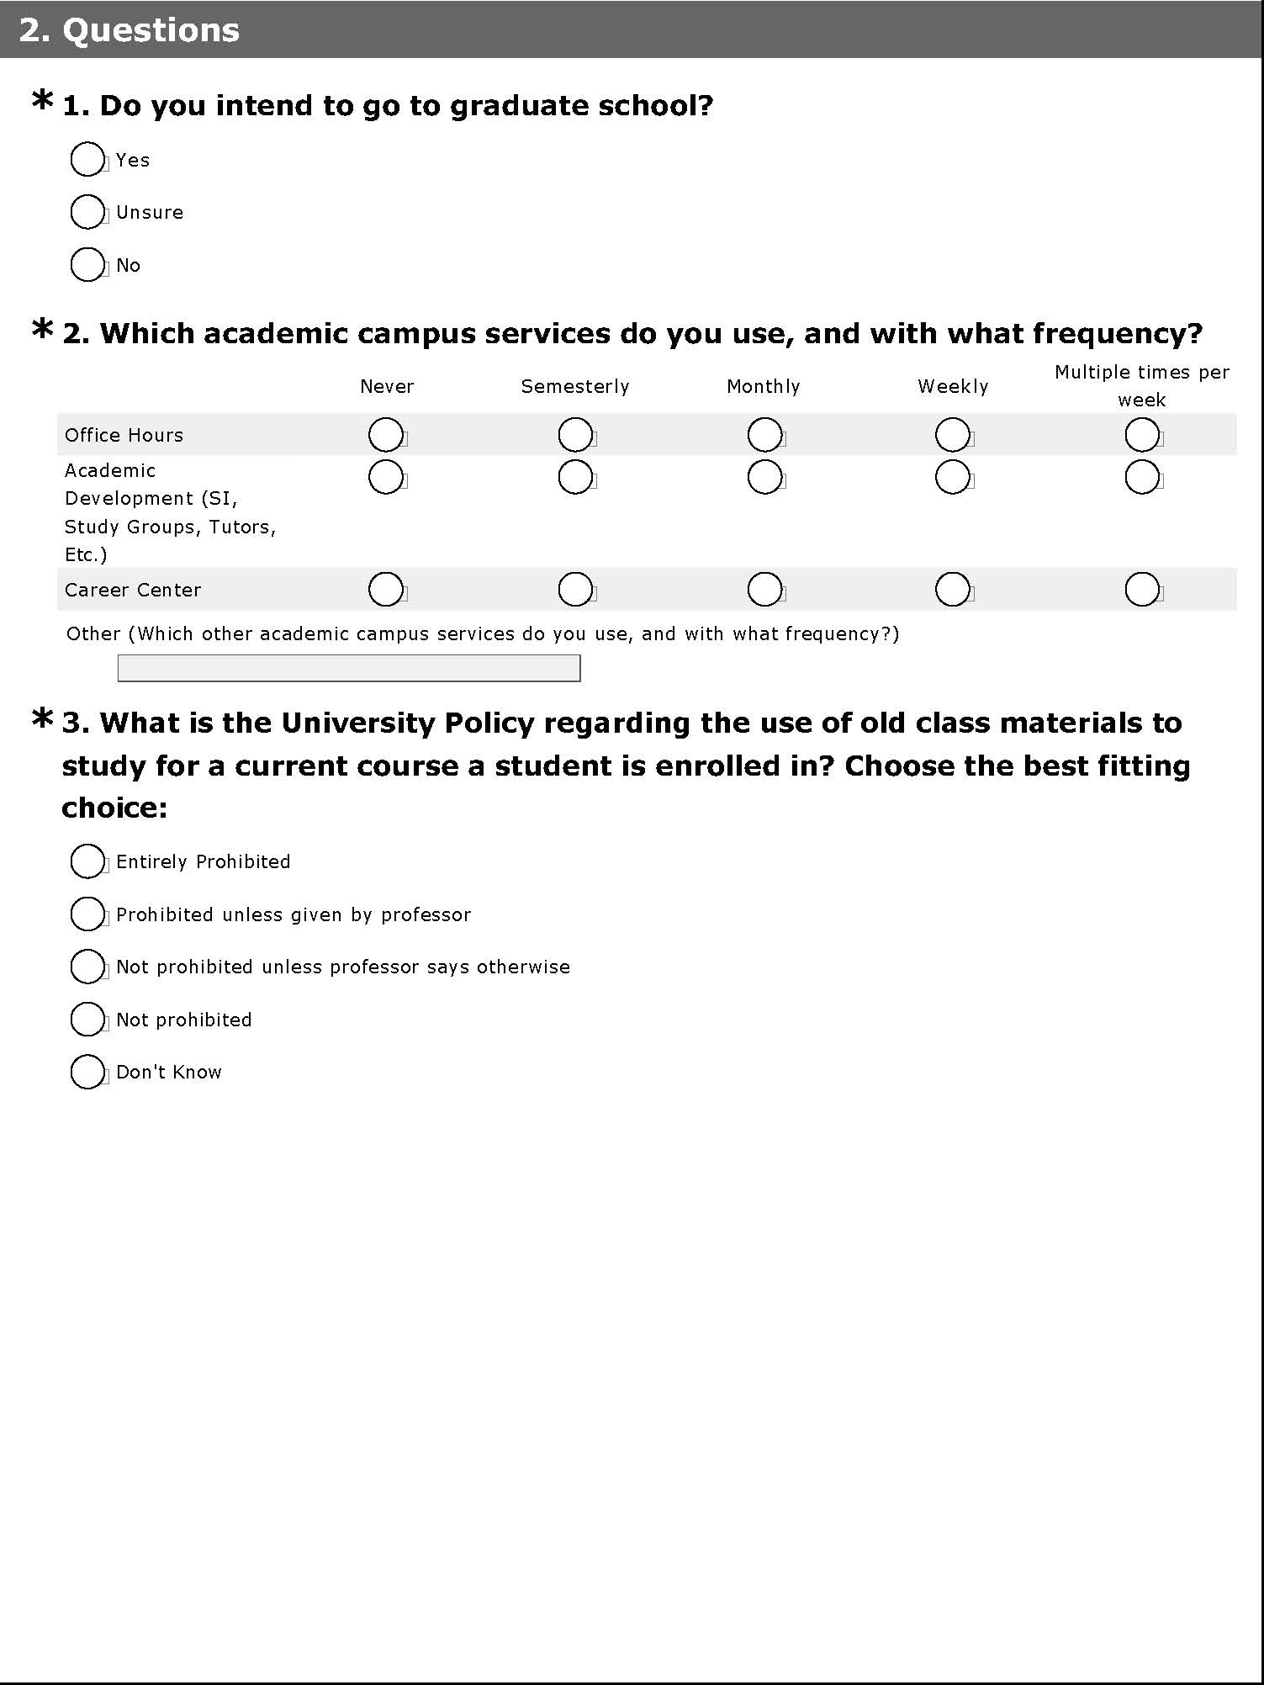

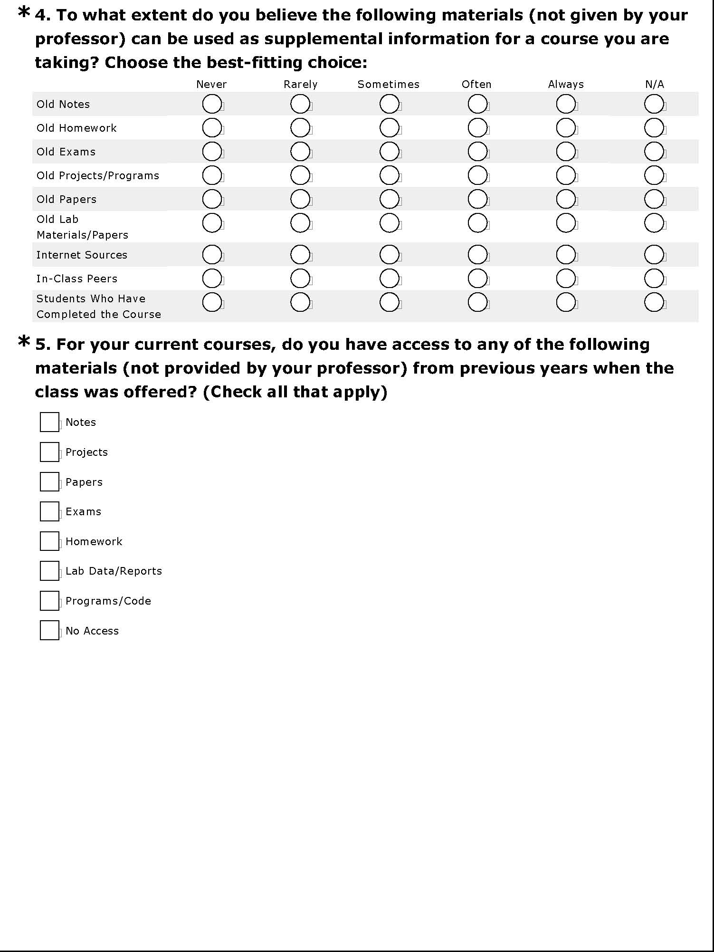



*If the respondent said they had access the were asked the following, if not, they were directed to the next page.*

**1. What is the source of your access?**

Fraternity/Sorority

Officially Recognized CMU Student Organizations

Informal Social Networks

Other (please specify)

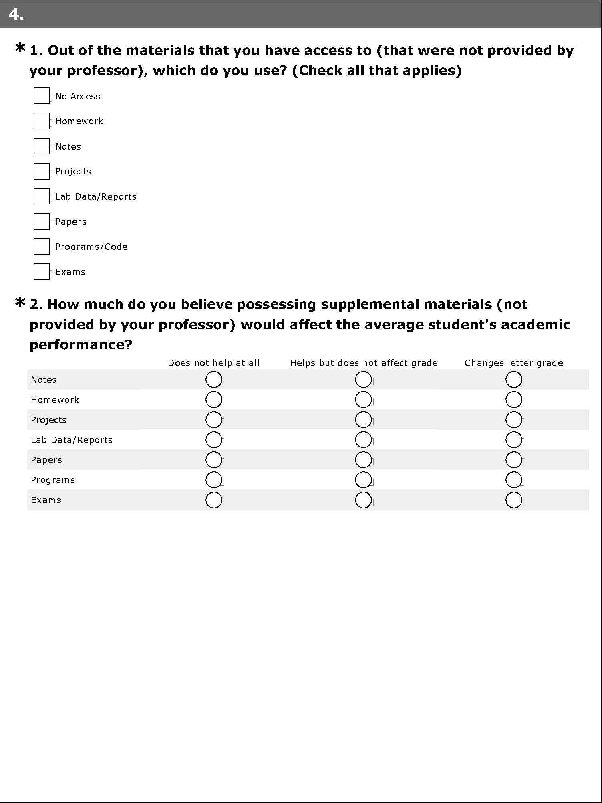

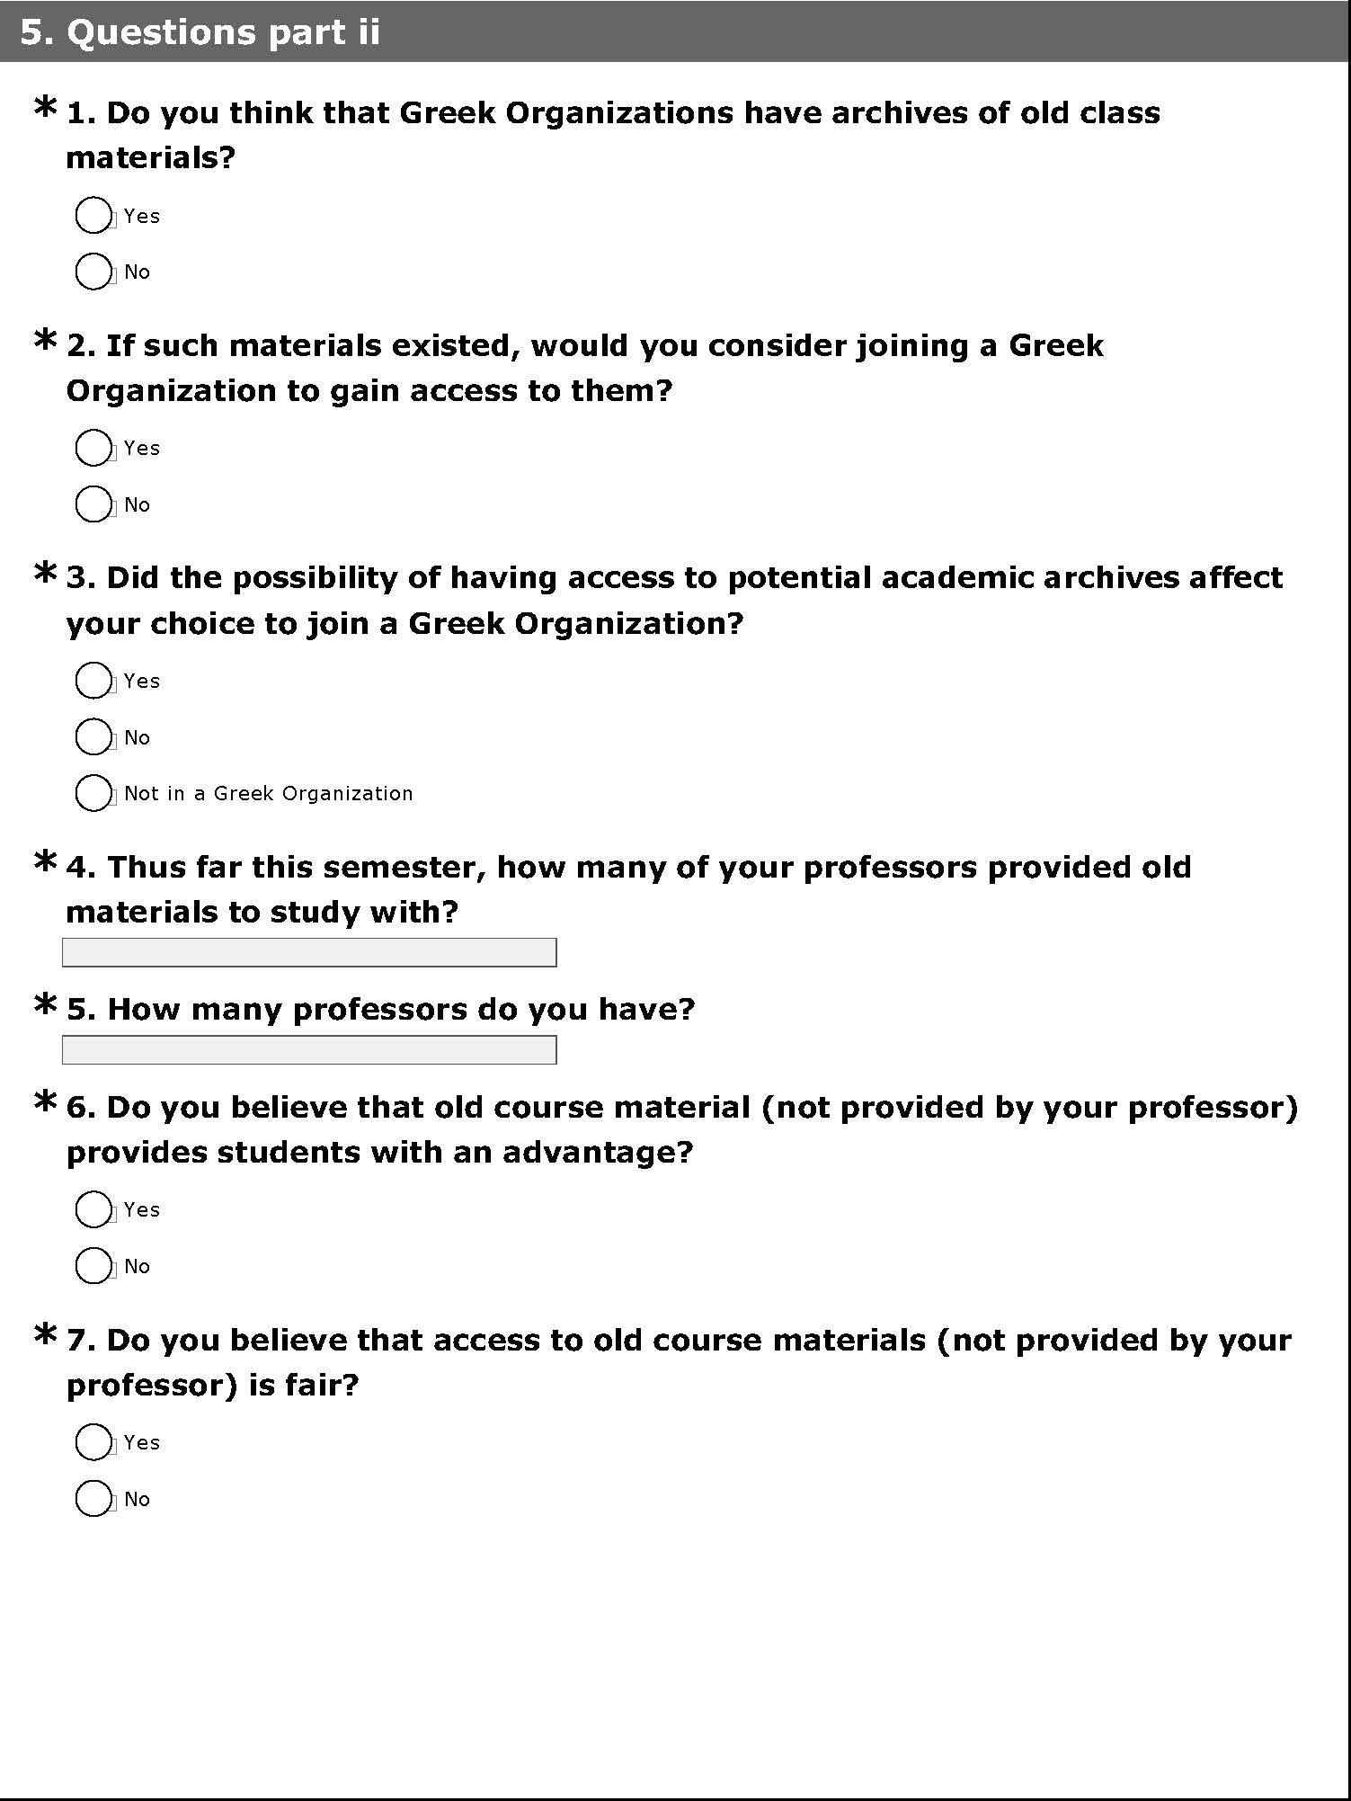

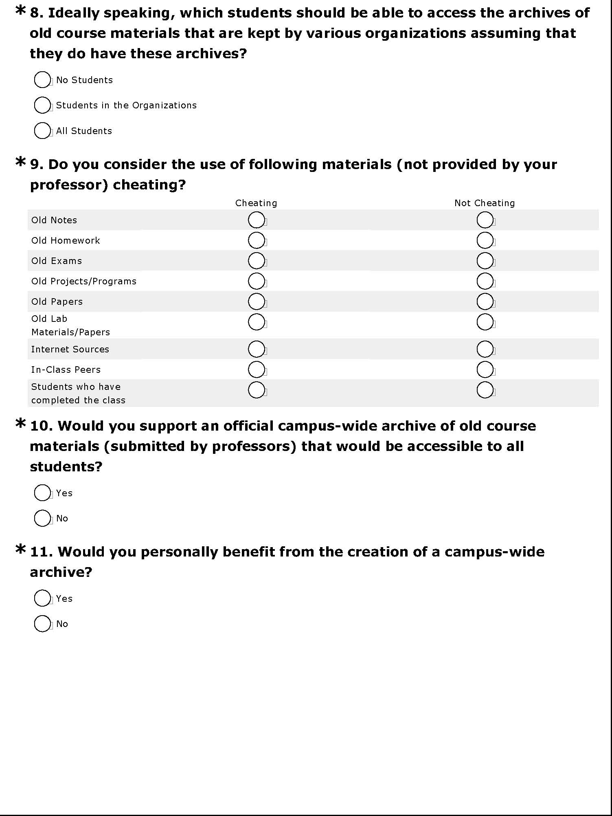

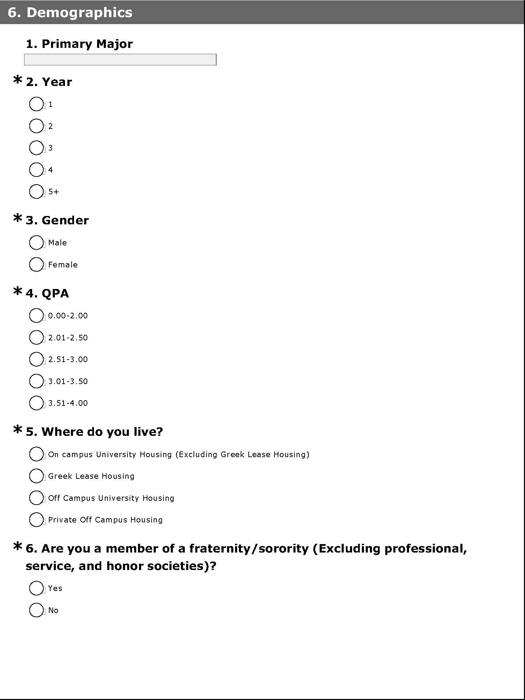

**\*7. Are you currently a member of an officially recognized campus student organization (Not including a fraternity or sorority)?**

Yes

No



Thank you very much for completing our survey. Have a nice day :)