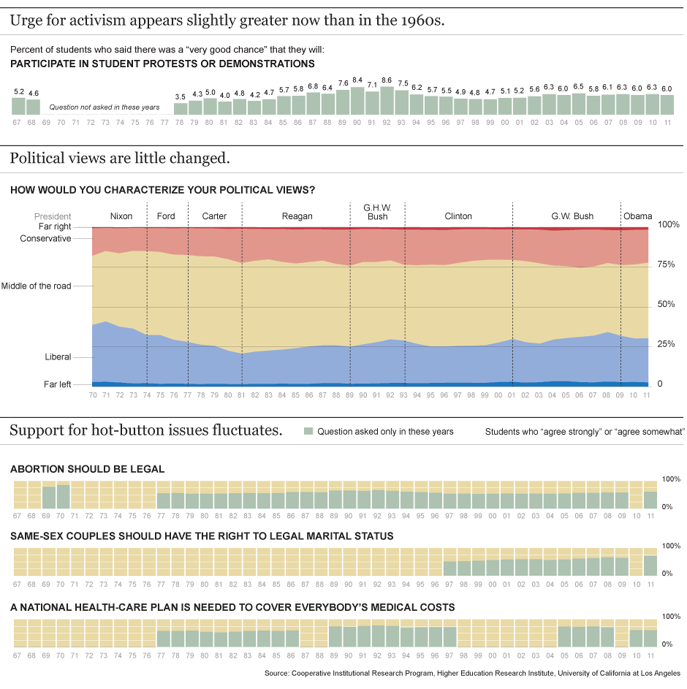January 26, 2012

**Survey Tracks Changes in Political Views of Freshmen**

Four decades of data reveal shifts in first-year students' attitudes on politics.